THE UNIVERSITY OF BAMENDA



COLLEGE OF TECHNOLOGY

(COLTECH)

DEPARTME
NT OF
COMPUTER ENGINEERING

CyberForge: A Real-Time Agentic AI System for Web Threat Detection and User Protection

A Dissertation submitted to the Department of Computer Engineering of the
College of Technology in partial Fulfillment of the requirements for the award of a Master’s Degree in Computer Engineering – Information Technology and Cyber Security

BY:
CHE HAGGAI NGHA KANG
REGISTRATION NUMBER: UBA24PP134
(B.Tech in Computer Engineering)

SUPERVISED BY:
Prof. ONABID MATHIAS AKONG
ASSOCIATE PROFESSOR

JUNE, 2026

DECLARATION
I, CHE HAGGAI NGHA KANG (Registration Number: UBA24PP134), hereby declare that this dissertation entitled “CyberForge: A Real-Time Agentic AI System for Web Threat Detection and User Protection” is my own original work. It has been written by me and has not been submitted, in part or in whole, for the award of any other degree or qualification at this university or any other institution. All sources of information used in this work have been duly acknowledged through references.

Signature: …………………………………. Date: ………………………………….
CHE HAGGAI NGHA KANG
(Candidate)

CERTIFICATION
This is to certify that this dissertation entitled “CyberForge: A Real-Time Agentic AI System for Web Threat Detection and User Protection” was carried out by CHE HAGGAI NGHA KANG (Registration Number: UBA24PP134) in the Department of Computer Engineering, College of Technology, The University of Bamenda, under our supervision.

Signature: …………………………………. Date: ………………………………….
Prof ONABID MATHIAS AKONG
(Supervisor)

Signature: …………………………………. Date: ………………………………….
[Dr SUH CHARLSE FORBACHA]
(Head of Department)

ABSTRACT
The web browser has become the main door through which cyber-attacks reach ordinary users, yet most existing defences either depend on fixed signatures that attackers easily avoid or on single machine-learning models that raise too many false alarms and cannot explain their decisions. This study designed, implemented, and evaluated CyberForge, a real-time, multi-platform cybersecurity system that uses several cooperating artificial-intelligence agents to analyse every URL a user visits and to protect the user while browsing. The system decomposes URL analysis into eight specialised agentsa Transformer-based URL classifier, a domain-generation-algorithm (DGA) detector, a web scraper, a memory reader, an indicator-of-compromise (IOC) extractor, a behavioural analyser, a MITRE ATT&CK mapper, and a threat-intelligence enricher coordinated through a three-stage directed acyclic graph and combined by a reporter agent into one explainable verdict. A large-language-model fallback chain turns the technical findings into plain-language explanations, while a memory layer stores past results so that the system learns from earlier browsing activity. The system was evaluated on 300 URLs (150 safe and 150 harmful). It achieved an overall accuracy of 94.7 %, a precision of 97.9 %, a false-positive rate of 2.0 %, and a mean end-to-end analysis time of about 4 seconds per URL, with cached repeat visits returning in under 100 ms. These results show that breaking a single browser event into multiple specialised agents produces richer, more reliable, and more explainable protection than a single model, at a speed that does not disturb normal browsing.
Keywords: agentic AI; phishing detection; multi-agent systems; threat intelligence; real-time protection; explainable security

RESUME
CyberForge : un système d’IA agentique en temps réel pour la détection des menaces web et la protection des utilisateurs
Le navigateur web est devenu la principale porte par laquelle les cyberattaques atteignent les utilisateurs ordinaires. Pourtant, la plupart des défenses existantes reposent soit sur des signatures fixes que les attaquants contournent facilement, soit sur des modèles d’apprentissage automatique uniques qui produisent trop de fausses alertes et ne peuvent pas expliquer leurs décisions. Cette étude a conçu, mis en œuvre et évalué CyberForge, un système de cybersécurité multiplateforme en temps réel qui utilise plusieurs agents d’intelligence artificielle coopérants pour analyser chaque URL visitée par l’utilisateur et le protéger pendant la navigation. Le système décompose l’analyse d’une URL en huit agents spécialisésun classificateur d’URL basé sur un Transformer, un détecteur d’algorithmes de génération de domaines (DGA), un extracteur de contenu web, un lecteur de mémoire, un extracteur d’indicateurs de compromission (IOC), un analyseur comportemental, un agent de correspondance MITRE ATT&CK et un agent d’enrichissement en renseignement sur les menacescoordonnés par un graphe orienté acyclique en trois étapes et combinés par un agent rapporteur en un verdict unique et explicable. Une chaîne de repli de grands modèles de langage transforme les résultats techniques en explications simples, tandis qu’une couche de mémoire conserve les résultats antérieurs afin que le système apprenne de l’activité de navigation passée. Le système a été évalué sur 300 URL (150 sûres et 150 dangereuses). Il a atteint une précision globale de 94,7 %, une précision des alertes de 97,9 %, un taux de fausses alertes de 2,0 % et un temps d’analyse moyen d’environ 4 secondes par URL, les visites répétées en cache étant traitées en moins de 100 ms. Ces résultats montrent que la décomposition d’un événement de navigation en plusieurs agents spécialisés produit une protection plus riche, plus fiable et plus explicable qu’un modèle unique, à une vitesse qui ne perturbe pas la navigation normale.
Mots-clés : IA agentique ; détection du phishing ; systèmes multi-agents ; renseignement sur les menaces ; protection en temps réel ; sécurité explicable

DEDICATION
This work is dedicated to my mother, NGAH EVELYN NJUA, whose love, sacrifice, and unshakable faith in me have carried me through every stage of my education. You gave up so much so that I could sit in a classroom, and every page of this dissertation is a fruit of your prayers and your patience.

To my elder brothers, KUM MEH FRANCIS and CHE FLORIMUND KUM-KAH, who stood in for me in countless ways, encouraged me when the road was hard, and reminded me that giving up was never an option.

And to my elder sister, CHE EGLAH MBONG, for her constant care, quiet strength, and the example she set for me long before I understood what perseverance meant.

This achievement is not mine alone it belongs to all of you.

ACKNOWLEDGEMENTS
I sincerely thank my supervisor, Prof ONABID MATHIAS AKONG, for the patient guidance, careful corrections, and steady encouragement that shaped this work from its first idea to its final form.
I am grateful to the Head of Department and to all the lecturers of the Department of Computer Engineering, College of Technology, The University of Bamenda, for the knowledge and training they gave me throughout my studies.
I thank my family for their unending support, prayers, and sacrifices, and my friends and classmates for their helpful discussions, testing assistance, and encouragement during the long hours of development and writing.
Finally, I acknowledge the open-source community whose freely available tools, models, and data sets including Hugging Face, MITRE ATT&CK, and AlienVault OTX made it possible to build and evaluate this system.

TABLE OF CONTENTS
DECLARATION iv
CERTIFICATION v
ABSTRACT vi
RESUME vii
DEDICATION viii
ACKNOWLEDGEMENTS ix
TABLE OF CONTENTS x
LIST OF TABLES xiv
LIST OF FIGURES xv
LIST OF ABBREVIATIONS xvi
Chapter One INTRODUCTION 1
1.1 Background of the Study 1
1.2 Problem Statement 2
1.3 Research Questions 3
1.3.1 General Research Question 3
1.3.2 Specific Research Questions 3
1.4 Objectives of the Study 4
1.4.1 General Objective 4
1.4.2 Specific Objectives 4
1.5 Significance of the Study 4
1.6 Scope and Limitations of the Study 5
1.7 Definition of Key Terms 6
1.8 Arrangement of the Dissertation 9
Chapter Two LITERATURE REVIEW 11
2.1 Introduction 11
2.2 Evolution of Web Threats 12
2.3 Machine Learning in Cybersecurity 13
2.3.1 Foundational scepticism 13
2.3.2 Surveys of applied machine learning 14
2.3.3 Deep learning and Transformers 14
2.4 Related Works: Phishing Detection Approaches 15
2.5 Domain Generation Algorithms (DGA) 16
2.6 Indicator Extraction and Cyber Threat Evidence Representation 18
2.7 Structured Adversary Behaviour Mapping Using MITRE ATT&CK 19
2.8 Multi-Agent Systems and Agent-Based AI in Cybersecurity 20
2.8.1 Classical idea of multi-agent systems 20
2.8.2 Agentic AI and modern systems 20
2.8.3 How agents are coordinated 21
2.9 Large Language Models, Sandboxing, Threat Intelligence, and Cross-Platform Security 22
2.9.1 Large Language Models in security systems 22
2.9.2 Sandboxing and behavioural analysis in cybersecurity 23
2.9.3 Threat intelligence systems 23
2.9.4 Cross-platform security architectures 24
2.10 Research Gaps 25
Chapter Three MATERIALS AND METHODS 27
3.1 Introduction 27
3.2 System Architecture 28
3.2.1 System Flow (High-Level View) 29
3.2.2 Summary of Architecture Idea 31
3.3 Use Case: User Browses a URL 32
3.4 System Flow Chart 35
3.5 Class Diagram 39
3.6 Materials 41
3.6.1 Hardware 41
3.6.2 Software 41
3.6.3 Key Libraries 41
3.6.4 Services 42
3.6.5 Public Datasets 42
3.7 Methodology 42
3.7.1 Software-Development Methodology 42
3.7.2 Calibration of the Risk-Score Formula 43
3.7.3 Calibration of the DGA Heuristic 44
3.7.4 Verification of the LLM Fallback Chain 44
3.8 The Eight-Agent Analysis Pipeline 44
3.9 Evaluation Methodology 47
Chapter Four RESULTS AND DISCUSSION 48
4.1 Introduction 48
4.2 System Performance and Latency 49
4.2.1 Real-Time Dashboard 51
4.3 Threat Detection Accuracy 52
4.3.1 Threat Alerts 53
4.4 Contribution of Each Agent 54
4.5 AI-Written Explanations 56
4.5.1 Explanation and Assistant Views 57
4.6 Reliability of External Services 58
4.7 Protective Actions and Reporting 60
4.8 Summary of Objectives Met 62
4.9 Conclusion of Results 62
Chapter Five CONCLUSION, RECOMMENDATIONS AND PERSPECTIVES 64
5.1 Conclusion 64
5.2 Recommendations 64
5.3 Perspectives 65
REFERENCES 67
APPENDIX A: CALIBRATION URL SET 70
APPENDIX B: KEY SERVICE ENDPOINTS 71

LIST OF TABLES
Table 3.1 | The CyberForge eight-agent analysis pipeline
Table 4.1 | End-to-end latency by pipeline stage
Table 4.2 | Average processing time for individual agents
Table 4.3 | Threat-detection results by URL category
Table 4.4 | Overall classification metrics
Table 4.5 | Agent contribution and reliability
Table 4.6 | Quality of AI-written explanations
Table 4.7 | External-service reliability during the test period
Table 4.8 | Objectives and outcomes
Table A.1 | The seven-URL calibration set and expected verdicts
Table B.1 | Principal API endpoints of the deployed system

LIST OF FIGURES
Figure 3.1 | CyberForge system architecture
Figure 3.2 | Use-case diagram for the principal interaction
Figure 3.3 | CyberForge system flow chart
Figure 3.4 | Class diagram of the backend orchestrator
Figure 4.1 | The CyberForge main dashboard (Threat Overview)
Figure 4.2 | The Agent Core screen with the eight-agent pipeline
Figure 4.3 | The real-time threat alert window
Figure 4.4 | The Alerts and Evidence screen (Threat Centre)
Figure 4.5 | The Model Inference screen
Figure 4.6 | The Signal Pipeline screen
Figure 4.7 | The Sandbox screen with the detonation chamber and verdict
Figure 4.8 | The AI Assistant screen
Figure 4.9 | The Memory screen with stored scan records
Figure 4.10 | The Threat Globe screen with live OTX intelligence
Figure 4.11 | The Security Functions screen
Figure 4.12 | The Reports screen
Figure 4.13 | The authentication screen of the deployed application

LIST OF ABBREVIATIONS
AI | Artificial Intelligence
API | Application Programming Interface
APA | American Psychological Association
ATT&CK | Adversarial Tactics, Techniques, and Common Knowledge
BERT | Bidirectional Encoder Representations from Transformers
CSRF | Cross-Site Request Forgery
CVE | Common Vulnerabilities and Exposures
DAG | Directed Acyclic Graph
DGA | Domain Generation Algorithm
DOM | Document Object Model
EDR | Endpoint Detection and Response
HTML | HyperText Markup Language
HTTP/HTTPS | HyperText Transfer Protocol (Secure)
IOC | Indicator of Compromise
IP | Internet Protocol
IPC | Inter-Process Communication
LLM | Large Language Model
MAS | Multi-Agent System
ML | Machine Learning
MSSP | Managed Security Service Provider
OTX | Open Threat Exchange
PaaS | Platform as a Service
PII | Personally Identifiable Information
SOAR | Security Orchestration, Automation and Response
SOC | Security Operations Centre
SQL | Structured Query Language
TLD | Top-Level Domain
TTP | Tactics, Techniques, and Procedures
UI | User Interface
URL | Uniform Resource Locator
XDR | Extended Detection and Response
XSS | Cross-Site Scripting

Chapter One
INTRODUCTION

1.1 Background of the Study
The volume, complexity, and impact of cyber-attacks have increased steadily since the early 2000s, with the World Wide Web becoming the main attack surface for both individuals and organisations (Provos et al., 2007). As cloud services, modern browsers, and web applications continue to grow, the security boundary has shifted away from traditional network firewalls to the user’s browser. In this environment, threats such as phishing, drive-by downloads, credential theft, malicious ads, and supply-chain attacks are now very common and highly damaging (Khonji et al., 2013). Traditional signature-based security systems are no longer effective because attackers now use fast-changing domains, hidden payloads, and short-lived infrastructure to avoid detection.
To respond to this, researchers first used machine-learning methods and later moved into deep-learning approaches. Early studies showed that machine learning could help detect malware and phishing attacks, but they also highlighted problems like noisy data, changing attack patterns, and difficulty in real-world deployment. Later research showed that deep-learning models, especially those that analyse raw URL text and character patterns, perform better than manual feature-based systems. The introduction of Transformer models improved this further by allowing systems to understand context in sequences like URLs and logs (Devlin et al., 2019). These methods have made it easier to build automated security tools for real-world use (Buczak & Guven, 2016).
At the same time, cybersecurity systems are moving away from single-model designs to multi-component systems made of specialised agents (Yao et al., 2023). In this approach, different agents handle different tasks such as detection, extraction, analysis, and reporting. These agents work together to make better decisions than a single model could achieve alone. This idea fits well with cybersecurity work because human analysts also follow step-by-step reasoning when checking suspicious URLs, such as checking reputation, analysing page behaviour, and mapping threats to known attack patterns like MITRE ATT&CK (Strom et al., 2018).
Another key issue is that users now operate across many devices, including desktops, mobile phones, and cloud platforms, but security systems are often not connected across these environments. This creates gaps in protection and makes it harder to maintain consistent threat awareness. Because of this, there is growing interest in systems that can share and synchronise threat intelligence across platforms, although such systems are still not common in most practical or academic tools.
The present study, CyberForge, is developed in response to these challenges. It is a multi-platform, agent-based cybersecurity system designed to analyse URLs in real time and protect users while they browse. The system uses multiple specialised agents to handle tasks such as URL classification, domain analysis, behavioural inspection, threat-intelligence lookup, and adversary mapping. These agents work together through a coordinated workflow to produce a final security verdict.
To improve continuity, the system also includes a memory layer that stores past observations and domain activity, allowing it to detect repeated or long-term threats. In addition, a fallback mechanism using large language models ensures that the system can still generate explanations and alerts even when some components are unavailable. The system has been tested using real-world URLs to evaluate its ability to detect threats, reduce risks, and provide timely user protection.

1.2 Problem Statement
Despite the considerable academic literature on machine learning for cybersecurity, and despite the commercial maturity of products such as Endpoint Detection and Response (EDR) platforms, three persistent problems continue to limit the practical usefulness of AI-based threat detection for ordinary users and for small organisations.
First, single-model approaches to URL and content classification are prone to high false-positive rates. Early experimental work in the present project found that a hand-tuned heuristic risk-score formula was systematically returning a “medium” risk verdict for every URL evaluated including safe sites such as google.com and github.com because of an additive baseline offset of +0.5 in the score-normalisation step. That defect illustrates a broader problem: models trained on synthetic or imbalanced data tend to inherit biases that are not detectable until deployment, and the result is a tiring volume of alerts that makes users ignore genuine threats.
Second, the explainability gap between an AI-generated verdict and the reasoning a security analyst would use to justify that verdict is rarely closed in current tools. A single classifier might output a probability that a URL is malicious, but it cannot, on its own, list the indicators of compromise present on the page, map observed JavaScript activity to a MITRE technique, or link the domain with prior threat-intelligence reports. The analyst, or the end user, is therefore left with a number rather than a clear story.
Third, there is no widely deployed open architecture that fans a single browser event out across a set of specialised analysers, saves the combined result, learns from prior visits, and shows the result on the user’s desktop and mobile device at the same time. Commercial Security Orchestration, Automation and Response (SOAR) platforms meet this need at the enterprise scale, but they are out of reaching both price and complexity for the academic-research and small-team settings in which this dissertation is situated.
CyberForge has been built to address these three problems together: it replaces the single classifier with an eight-agent ensemble, it generates a structured analytic report in which each agent’s contribution can be checked independently, and it synchronises that report across the desktop client, the cloud back-end, and the persistent memory store.

1.3 Research Questions

1.3.1 General Research Question
How can a multi-agent AI system, organised as a network of specialised analysers, be designed to provide real-time and explainable threat intelligence and protection for URLs and web resources across different platforms?

1.3.2 Specific Research Questions
- How can the analysis of a URL be divided among different AI agents, and what is the smallest set of agents needed to make a reliable threat assessment?
- How can URL classification, behavioural analysis, IOC extraction, MITRE ATT&CK mapping, and threat-intelligence lookup be combined into a single system that produces consistent and accurate threat assessments?
- What method can be used to combine the results from different agents to reduce false alarms while still identifying serious threats when strong evidence is available?
- How can historical browsing information be used to improve threat detection, identify recurring malicious activity, and strengthen user protection over time?

1.4 Objectives of the Study

1.4.1 General Objective
To design, implement, and evaluate a multi-platform AI-driven cybersecurity system that can monitor URLs encountered during web browsing in real time, detect and explain potential threats using multiple cooperating agents, and provide timely alerts and protective feedback to users while maintaining historical context and persistent threat records.

1.4.2 Specific Objectives
- To design a multi-agent decision framework that can decompose URL analysis into coordinated tasks and produce reliable real-time threat assessments for user protection.
- To develop a unified threat-detection approach that combines multiple analytical perspectives (content, behavioural signals, structural patterns, and threat intelligence) to improve detection accuracy and consistency.
- To design a decision-aggregation mechanism that reduces false alerts while ensuring that high-confidence malicious indicators trigger immediate user warnings and protective actions.
- To incorporate contextual threat intelligence that improves detection quality by linking current URL behaviour with known attack patterns and external threat databases.

1.5 Significance of the Study
The significance of this study is threefold.
Academically, the project contributes a concrete reference implementation of a multi-agent web-threat-analysis system that combines techniques from machine learning (Transformer-based classification), heuristic engineering (entropy-based DGA detection), information retrieval (regular-expression-based IOC extraction), and threat-intelligence enrichment (OTX integration). The system is organised in such a way that any one component may be replaced independently, providing a base for future comparative studies. It also makes available, as an open codebase, a working example of how language-model fallback chains may be engineered for security applicationsa question that has received attention in commentary but has been treated only sparingly in the peer-reviewed literature.
Practically, the system corrects a class of false-positive defects that are widespread in heuristic risk-scoring systems. During development, a single change to the scoring formula reduced the false-positive rate on a curated test set of common safe URLs from one hundred per cent (every URL flagged as at least “medium” risk) to zero per cent, while preserving the system’s ability to detect known phishing patterns with 96.83 % confidence on the Transformer URL classifier.
Industrially, the selected technology stack (Heroku PaaS, Hugging Face Spaces, and the Appwrite backend-as-a-service) reflects modern cloud-native deployment practices widely used in scalable cybersecurity and AI systems. This architecture demonstrates how real-time threat-detection systems can be built using modular, service-oriented components that can be independently deployed, maintained, and scaled in production environments. It also aligns with industry trends toward API-driven security platforms, distributed AI inference, and cloud-based threat-intelligence pipelines, making the approach relevant for integration into enterprise security-monitoring tools, browser-protection systems, and managed security service provider (MSSP) environments.

1.6 Scope and Limitations of the Study
The scope of this study is defined as follows.
This research focuses on the design of a real-time, agent-based cybersecurity system that actively detects, responds to, and reduces threats encountered during web browsing. The system targets web-based attack surfaces such as phishing URLs, malicious or compromised domains, suspicious webpage content, and behavioural indicators derived from user interaction with web resources. In addition to detection and explanation, the system is designed to trigger protective actions such as user alerts, access warnings, request blocking, or escalation responses when high-risk activity is identified.
The study does not extend to low-level or infrastructure-level security domains. It excludes kernel-level exploitation, firmware attacks, hardware compromise, lateral movement within enterprise networks, and post-compromise persistence mechanisms that occur beyond the browser or user-interaction layer. The system is not intended to function as a full endpoint-protection suite or an enterprise intrusion-detection system.
Although the system incorporates analysis and security-enforcement capabilities, it is limited to web-context execution. It does not perform binary malware detonation in virtual machines, nor does it simulate full operating-system environments for deep dynamic analysis. Its protective actions are therefore restricted to browser-level and application-level interventions.
The system relies primarily on English-language threat-intelligence sources, classification models, and explanation frameworks. This includes structured cybersecurity knowledge bases such as MITRE ATT&CK and external threat-intelligence feeds such as AlienVault OTX. As a result, performance evaluation and interpretability are focused on English-language threat contexts.
From a deployment perspective, the system is designed for cloud-connected environments where detection, reasoning, and response components operate across distributed services. It is not optimised for fully offline, air-gapped, or strictly on-premises enterprise deployments.
Finally, the evaluation of the system focuses on detection accuracy, response effectiveness (alerting and blocking), false-positive reduction, explainability of decisions, and end-to-end response latency in real-time browsing conditions. Comparative benchmarking against commercial endpoint-security suites is outside the scope of this study.

1.7 Definition of Key Terms
- Agent (software). An autonomous computational unit that perceives an input, executes a task using its tools and internal state, and produces a structured output. In this dissertation, an agent is a JavaScript class implementing a single specialised analytic function within the eight-agent orchestrator (Wooldridge, 2009).
- Agentic AI. A class of artificial-intelligence system in which one or more specialised agents cooperate, possibly under the direction of a coordinator, to accomplish a task that none of them could complete alone (Russell & Norvig, 2020; Yao et al., 2023).
- API Gateway. A centralised interface layer that receives client requests, enforces authentication, and routes traffic to backend services. In CyberForge, it exposes endpoints for URL submission, agent-orchestration triggers, and result retrieval.
- Appwrite. An open-source backend-as-a-service platform providing authentication, document storage, and serverless functions. CyberForge uses Appwrite Cloud for user accounts, agent registration, scan-task persistence, and alert storage.
- Behavioural Analysis. A security-analysis technique that evaluates the runtime characteristics of a webpage or URLincluding network activity, script-execution patterns, cookie behaviour, and DOM manipulate onto detect suspicious or malicious activity.
- BERT. Bidirectional Encoder Representations from Transformers a pretrained Transformer architecture for natural-language understanding (Devlin et al., 2019). In CyberForge, a domain-adapted BERT model is used to classify URL strings.
- DAG (Directed Acyclic Graph). A graph in which edges have direction and no cycle exists. Used in this dissertation to describe the orchestrator’s stage structure, in which each stage may depend on outputs of an earlier stage.
- DGA (Domain Generation Algorithm). A class of algorithms used by malware families to generate large numbers of pseudo-random domain names for command-and-control rendezvous (Antonakakis et al., 2012).
- Evidence Locker. A persistent store of analytic records produced by the orchestrator. In CyberForge it consists of an in-process ring buffer mirrored to the Appwrite alerts collection.
- False Negative. A system outcome in which a malicious URL or resource is incorrectly classified as safe, representing a critical security failure in threat-detection systems.
- False Positive. A system outcome in which a safe URL or resource is incorrectly classified as malicious. Reducing false positives is a key objective of CyberForge’s aggregation strategy.
- Heuristic Analysis. A rule-based or statistical approach to threat detection that does not rely on trained models but instead uses predefined logic such as entropy scoring, pattern matching, or domain-structure evaluation.
- Hugging Face Spaces. A platform-as-a-service offering for hosting machine-learning demonstrations and APIs, used by CyberForge for both model inference (locally loaded Transformer pipelines) and remote inference (the Hugging Face Inference API).
- Inference Pipeline. The sequential process through which input data (such as a URL) is passed through multiple models and agents to generate a final classification or security verdict.
- IOC (Indicator of Compromise). A piece of forensic data that suggests the presence of a security incident for example an IP address, a domain, a file hash, or a CVE identifier.
- LLM (Large Language Model). A neural network with billions of parameters trained on large text corpora and capable of generating natural-language responses to prompts (Brown et al., 2020).
- Memory Layer. A multi-store persistence system used to retain historical threat data across sessions. In CyberForge, it combines in-memory storage, Redis caching, and vector-based similarity search to support contextual threat detection.
- MITRE ATT&CK. A globally accessible knowledge base of adversary tactics and techniques based on real-world observations, maintained by the MITRE Corporation (Strom et al., 2018).
- Multi-Agent System. A distributed artificial-intelligence architecture composed of multiple specialised agents that independently process subtasks and collaboratively produce a unified output.
- Orchestrator. In CyberForge, the back-end service responsible for dispatching agents through the three-stage DAG, aggregating their outputs, escalating verdicts, and persisting the consolidated report.
- OTX (Open Threat Exchange). AlienVault’s open threat-intelligence sharing platform, used by CyberForge as a source of reputation lookups for extracted IOCs.
- Phishing URL. A malicious web address designed to impersonate a legitimate service in order to steal sensitive user information such as credentials or financial data.
- Real-Time Processing. The ability of the system to analyse, classify, and respond to incoming URLs with minimal delay while the user is actively browsing.
- Risk Score. A numerical or categorical value generated by the system to represent the likelihood that a URL or web resource is malicious, typically derived from aggregated agent outputs.
- Sandbox. In a security context, an isolated environment for analysing potentially malicious content. In CyberForge, the term refers to the user-facing screen at which static analytic results verdict, IOCs, MITRE chain, behavioural time line are surfaced.
- Threat Intelligence. External or internal data sources that provide information about known malicious domains, IPs, attack patterns, and adversary behaviour, used to improve detection accuracy.
- Transformer. The neural-network architecture introduced by Vaswani et al. (2017), foundational to BERT and to subsequent generations of language model.
- URL Classification. The process of analysing a URL string to determine whether it is benign, suspicious, or malicious using machine learning or heuristic methods.
- Vector Database. A specialised database optimised for high-dimensional similarity search over learned embeddings (Pinecone and ChromaDB are used in this work).
- Web Resource. Any content accessible via a URL, including webpages, scripts, media files, or dynamically generated content that may carry security risks.

1.8 Arrangement of the Dissertation
This dissertation is organised into five chapters.
Chapter 1: Introduction. This chapter introduces the research problem and motivates the need for real-time, explainable web-threat-detection systems. It presents the research questions, objectives, significance of the study, and scope of the work. It also provides an overview of the proposed system and defines key terms used throughout the dissertation.
Chapter 2: Literature Review. This chapter reviews existing research and technologies related to web security and intelligent threat detection. It covers the evolution of web-based threats, machine-learning approaches to intrusion detection, Transformer-based URL classification, DGA-detection techniques, the MITRE ATT&CK framework, multi-agent systems, and the application of large language models in cybersecurity. The chapter concludes by identifying gaps in existing approaches that this study aims to address.
Chapter 3: Materials and Methods. This chapter presents the research methodology and system design. It describes the overall architecture of the proposed multi-agent cybersecurity system, including the orchestrator design, agent-coordination strategy, memory components, and data flow. It also outlines the tools, datasets, and evaluation methods used to assess system performance, focusing on real-time detection, alert generation, and protective response mechanisms.
Chapter 4: Results and Discussion. This chapter presents the implementation of the proposed system and evaluates its performance. It describes how the core components are realised, including the multi-agent framework, inference pipeline, memory layer, and user-facing interface. It then presents experimental results such as detection accuracy, false-positive and false-negative rates, response latency, and system effectiveness in generating alerts and protective actions. A discussion of these results is provided in relation to the research objectives and existing approaches.
Chapter 5: Conclusion, Recommendations and Perspectives. This chapter summarises the findings of the study and evaluates the extent to which the research objectives were achieved. It highlights the contributions of the proposed system to real-time web-threat detection and user protection. It also discusses limitations of the current system and provides recommendations for future improvements, including enhanced dynamic analysis, broader threat-intelligence integration, and more advanced adaptive learning mechanisms.

Chapter Two
LITERATURE REVIEW

2.1 Introduction
This chapter reviews existing research and systems that form the foundation of AI-driven cybersecurity, with particular focus on how artificial intelligence is increasingly being used not only to analyse threats, but also to actively protect users and digital environments in real time. The discussion is framed around the shift from traditional, rule-based security systems toward adaptive, learning-based systems capable of responding to modern and evolving cyber threats on the web.
A major focus of the review is the evolution of web-based threats and why conventional security mechanisms such as signature-based detection are no longer sufficient. Modern attacks, including phishing, malicious redirects, and dynamically generated domains, are designed to evade static rules. This has led to a growing need for intelligent systems that can learn patterns of malicious behaviour and respond proactively rather than reactively.
The chapter also examines how artificial intelligence and machine learning have changed the cybersecurity landscape by enabling systems to detect, classify, and respond to threats in real time. Unlike traditional approaches that depend on known threat signatures, AI-based systems can generalise from data and identify previously unseen attacks, making them more suitable for modern web environments where threats evolve continuously.
Beyond detection, recent research shows a clear shift toward AI systems that actively protect users during interaction with the web. This includes systems that can block malicious URLs, generate real-time warnings, interrupt harmful sessions, and adapt their responses based on observed behaviour. In this context, AI is no longer limited to passive analysis but is increasingly embedded in protective decision-making loops that directly influence user safety.
The review further explores URL-based and domain-generation-based detection methods, which remain central to browser-level protection systems. These methods are often enhanced using machine-learning models that analyse lexical patterns, entropy signals, and behavioural indicators to determine whether a web resource is safe or malicious.
Another important area covered is the extraction and interpretation of indicators of compromise (IOCs), which allow AI systems to connect observed web activity with known attack patterns. This capability supports not only detection but also contextual understanding, enabling systems to explain why a threat is considered dangerous and what type of attack may be involved.
The MITRE ATT&CK framework is also discussed as a structured knowledge base that helps map detected behaviours to known adversary tactics. This mapping improves both interpretability and response planning, allowing AI systems to move from simple classification toward structured security reasoning.
In addition, the chapter reviews the multi-agent-systems paradigm, which is increasingly used to distribute complex security tasks across specialised components. This approach enables parallel analysis of different threat signals such as URL structure, behavioural patterns, and external intelligence, improving both accuracy and response speed in real-time protection systems.
Closely related to this is the role of large language models in cybersecurity systems. While originally designed for language understanding and generation, these models are now being integrated into security pipelines to support reasoning, generate human-readable explanations, and assist in decision-making when other analytical components are uncertain. However, their integration also introduces challenges related to reliability and consistency in security-critical environments.
Finally, the chapter reviews prior work on distributed and cross-platform threat-intelligence systems, which aim to ensure that security insights can be shared and applied across multiple environments. This supports the broader goal of continuous protection, where intelligence is not isolated but reused to strengthen future threat detection and response.
Overall, the purpose of this chapter is not only to review existing work but to connect it directly to the problem of building intelligent systems that can actively protect users on the web. It highlights how current research supports the transition from passive cybersecurity tools to adaptive AI-driven systems capable of real-time detection, explanation, and protection against evolving web threats.

2.2 Evolution of Web Threats
The earliest body of academic work on web-based attacks concentrated on server-side vulnerabilities SQL injection, cross-site scripting (XSS), cross-site request forgery (CSRF), and remote file inclusion. Although those attack classes remain operationally significant, the center of gravity of consumer-facing web threats has shifted in the past fifteen years toward attacks that target the browser and the user directly. Provos, McNamee, Mavrommatis, Wang and Modadugu (2007), in their influential paper “The Ghost in the Browser,” documented the rise of drive-by-download attacks in which a legitimate page is silently modified to deliver an exploit chain to vulnerable browsers. Their large-scale crawl found that 1.3 % of the pages they sampled engaged in drive-by behaviour, and the authors argued presciently that the future of malicious web activity would be characterised by short-lived domains, polymorphic JavaScript, and infrastructure designed specifically to evade signature-based scanning.
The intervening fifteen years have validated that prediction. Khonji, Iraqi and Jones (2013) provide a comprehensive literature survey of phishing detection covering more than seventy publications, observing that the most successful approaches combine lexical features of the URL, content features of the rendered page, and reputation features drawn from external feedsbut also noting that no single approach achieves both high recall and a low false-positive rate when evaluated on heterogeneous datasets. More recently, the increasing prevalence of free domain registrars (notably the .tk, .gq, .ml, .cf and .xyz zones) and the wide availability of phishing kits sold as a service have driven the cost of mounting a phishing campaign close to zero. Anderson and Roth (2018), in introducing the EMBER static-PE-malware benchmark, similarly noted that the half-life of malware family signatures has continued to shrink, making per-sample classification increasingly important relative to per-family classification.
The implication for system design is that web-threat detection cannot rely on any single signal. A modern detector must combine string-level analysis of the URL, behavioural inspection of the page (DOM, network requests, JavaScript activity), reputation lookups in third-party feeds, and longitudinal context drawn from past observations of the same domain or actor. The eight-agent decomposition adopted by CyberForge is a direct response to this multi-signal requirement.

2.3 Machine Learning in Cybersecurity

2.3.1 Foundational scepticism
Any review of machine learning in cybersecurity must begin with the foundational critique of Sommer and Paxson (2010). Their paper, “Outside the Closed World,” argued that the success of machine learning in domains such as natural-language processing and computer vision had not at the time of writing translated to comparable success in network intrusion detection, and identified the principal reasons: the cost of misclassification asymmetry, the lack of representative ground-truth data, the high variability of legitimate network behaviour, and the difficulty of converting model output into actionable artefacts for analysts. Although the specific landscape has changed considerably in the intervening years, the structural critique remains relevant; in particular, the requirements that model output be interpretable and that systems be designed for cost-asymmetric misclassification continue to inform the design of any production deployment.

2.3.2 Surveys of applied machine learning
Buczak and Guven (2016) provide a systematic review of the application of classical machine-learning methods decision trees, support-vector machines, random forests, hidden Markov models, and clustering techniques to intrusion detection. Their summary is mixed: in controlled benchmark conditions, ensemble methods such as random forests routinely achieve accuracy above 95 %, but the gap between benchmark performance and operational performance remains pronounced. They identify three contributors to this gap: (i) concept drift, in which the statistical properties of normal traffic change over time; (ii) class imbalance, in which malicious samples are vastly outnumbered by benign ones; and (iii) the absence of labelled adversarial examples. Their recommendations that systems combine multiple classifiers, that they be re-trained on operational data, and that they expose calibrated probability outputs are directly reflected in CyberForge’s design.

2.3.3 Deep learning and Transformers
The publication of Vaswani et al.’s “Attention Is All You Need” (2017) and the subsequent introduction of BERT (Devlin et al., 2019) shifted the deep-learning research community from convolutional and recurrent architectures toward self-attention-based Transformers. While the original BERT was trained on a general English corpus (BookCorpus plus the English Wikipedia), the pre-training-and-fine-tuning paradigm proved remarkably adaptable to specialised domains. Domain-adapted BERT variants for biomedicine (BioBERT), law (LegalBERT), source code (CodeBERT), and security applications now form a substantial sub-literature.
For URL classification specifically, several authors have demonstrated that a Transformer model can outperform handcrafted feature engineering. Le, Pham, Sahoo and Hoi (2018) introduced URLNet, a character- and word-level convolutional architecture that achieved state-of-the-art performance on the URL-classification task at the time of publication; subsequent work has shown that BERT-style models, fine-tuned on phishing- and malware-URL corpora, achieve further marginal improvements at the cost of higher inference latency. CyberForge consumes the publicly available elftsdmr/malware-url-detect model hosted on Hugging Face, which is itself a fine-tune of bert-base-multilingual-cased; the design decision to use an off-the-shelf, externally validated model rather than to train one in-house was made for two reasons: (i) the open-weight model is independently reproducible by any reader of this dissertation, and (ii) the principal scientific contribution of the present study is the orchestration of multiple analyses, not the training of a single classifier.

2.4 Related Works: Phishing Detection Approaches
Phishing detection is one of the most studied problems in web security because it directly targets human users through deception rather than system exploitation. Over time, research in this area has evolved in clear stages, moving from simple rule-based systems to advanced machine learning and now to deep-learning and Transformer-based approaches. Each stage improves detection ability, but also introduces new trade-offs between accuracy, adaptability, and interpretability.
The early stage of phishing detection was mainly based on rule-based or feature-based methods. These systems relied on manually defined indicators extracted from URLs or webpage content. Common features included URL length, the use of suspicious symbols such as “@” or “-”, IP addresses used in place of domain names, abnormal subdomain structures, and HTML elements such as hidden iframes or forms. Works such as Mohammad, Thabtah, and McCluskey (2014) show that these approaches could achieve good performance under controlled conditions. However, their main weakness was rigidity. Once attackers understood the rules being used, they easily modified their phishing URLs to bypass detection. This made rule-based systems less effective over time, especially against adaptive adversaries.
The second stage introduced classical machine-learning models, which reduced dependence on fixed rules by learning patterns from data. Instead of hard-coded detection logic, models such as decision trees, support-vector machines, and random forests were trained on extracted URL and webpage features. Studies like Sahingoz et al. (2019) demonstrated that machine-learning models could achieve very high accuracy, with ensemble methods such as random forests performing particularly well on lexical URL features. This generation of approaches was more flexible than rule-based systems and could generalise better to unseen data. However, they still depended heavily on feature engineering, meaning their performance was limited by how well human experts could design meaningful input features. They also struggled when attackers introduced subtle changes that were not captured by existing feature sets.
The third and more recent stage is based on deep learning, especially neural networks and Transformer architectures. In this approach, the system no longer relies on manually designed features. Instead, models learn directly from raw URL strings or tokenised representations. Transformer-based models, in particular, can capture relationships between characters and tokens in a URL, allowing them to detect patterns that are not obvious through manual analysis. This makes them more resilient to small manipulations such as character substitution or URL-obfuscation techniques commonly used in phishing attacks. However, these models are usually more computationally expensive, require more data, and are less transparent compared to traditional machine-learning models.
Despite their advantages, deep-learning models alone are not always sufficient in practical security environments. This is because real-world systems require reliability, fallback mechanisms, and interpretability under failure conditions. As a result, many modern systems adopt hybrid designs that combine deep learning with traditional methods. This allows systems to benefit from the accuracy of neural models while still maintaining simpler heuristic or rule-based components for backup and verification.
In line with this direction, CyberForge adopts a hybrid phishing-detection approach, consistent with the survey finding that combined detection signals outperform any single approach (Khonji et al., 2013). It combines a Transformer-based URL classifier for high-accuracy detection with a lightweight heuristic-analysis layer that can operate when the primary model is unavailable or uncertain. This design improves system resilience and ensures continuous operation even under service degradation. It also reflects a broader trend in cybersecurity research, where robustness and operational reliability are considered just as important as raw classification accuracy.

2.5 Domain Generation Algorithms (DGA)
Domain Generation Algorithms (DGAs) are techniques used by malware to automatically create large numbers of domain names. These domains are often used for command-and-control communication, making it difficult for defenders to block them using simple blacklists. Research in this area has developed over time, moving from statistical analysis to machine learning and more recently to deep-learning approaches.
The early and most influential work in this area is by Antonakakis et al. (2012). Their study showed that DGA-generated domains are very different from normal human-generated domain names. They tend to look random and do not follow natural language patterns. For example, they often have high character randomness (high entropy), very few vowels, unusual consonant combinations, and frequent mixing of numbers and letters. The study also showed that detecting a single malicious domain is not enough. Instead, it is more effective to detect groups of domains generated by the same algorithm, since malware families usually produce many related domains over time. This idea became the foundation for many later DGA-detection systems.
After this, researchers started using machine-learning methods to improve detection accuracy. Instead of relying only on statistical rules, models were trained on examples of both normal and DGA-generated domains. Some studies showed that character-based neural networks could learn patterns directly from domain names and perform better than traditional statistical approaches. Later work also explored deep-learning models, including convolutional networks and Transformer-based models, which can capture deeper relationships in character sequences and improve detection of more advanced DGAs.
However, in real-world systems, DGA detection is not only about accuracy but also about reliability and integration. Deep-learning models can be powerful, but they are often harder to deploy, depend on external services, or require heavy computation. Because of this, many practical systems still rely on simpler but stable statistical or heuristic methods, especially when working in real-time environments.
In CyberForge, DGA detection follows this practical approach. Instead of relying only on a complex external model, the system uses a lightweight heuristic method based on well-known DGA characteristics. These include Shannon entropy, vowel-to-consonant ratio, digit ratio, and patterns in character repetition such as long consonant runs. These signals are combined into a single score that helps determine whether a domain is likely generated by malware.
This approach is intentionally designed to be simple, fast, and reliable. It is also flexible, meaning it can later be replaced or improved with a trained deep-learning model without changing the rest of the system. In this way, CyberForge keeps the balance between strong detection ability and practical deployment in real-time environments where speed and stability are important.

2.6 Indicator Extraction and Cyber Threat Evidence Representation
Indicators of Compromise (IOCs) come from real cybersecurity practice before they became a topic in academic research. They started as a simple way for security teams to share clear signs of an attack. When an incident happens, analysts need small pieces of evidence that prove something bad is going on. These pieces of evidence are what we call IOCs. They can include things like IP addresses, domain names, URLs, email addresses, file hashes, and sometimes even registry keys or malware signatures.
Over time, as cyber-attacks became more complex, sharing IOCs also became more structured. This led to the creation of standards like STIX and TAXII (Barnum, 2012). These standards made it possible for different security tools and organisations to exchange threat information in a common format. Instead of sending plain-text reports, systems could now send structured data that machines can understand and process automatically. This helped improve speed and coordination between security systems.
In research, different methods have been used to extract IOCs from data. Some methods use natural-language processing, where systems try to understand written reports and pull out useful security information (Liao et al., 2016). Other methods use machine-learning models that are trained to recognise patterns in text and identify possible indicators. More recent work even uses large language models to find security-related information from long documents. These methods are powerful, but they can also be complex, slow, or hard to control in real-time systems.
Because of this, many real-world security tools still rely on simple and direct methods for IOC extraction. One of the most common methods is pattern matching, especially regular expressions. This works by checking text against known patterns that match things like IP addresses, domain names, hashes, or URLs. This method is widely used because it is fast, easy to understand, and gives consistent results.
In CyberForge, IOC extraction is done directly from the content of web pages collected by the system. The extractor looks for several types of indicators. These include IPv4 and IPv6 addresses, domain names, URLs, email addresses, cryptographic hashes such as MD5, SHA-1, and SHA-256, Bitcoin wallet addresses, and CVE identifiers used for known software vulnerabilities.
This approach is chosen because it works well in real-time systems. Cybersecurity systems need to make quick decisions, so speed is very important. Another reason is clarity. When a system flags something as an IOC, a human analyst should be able to easily see why it was flagged. Regular expressions make this possible because the rule is simple and transparent.
The system also uses filtering rules to reduce false alerts. For example, not every domain name found on a page is dangerous. Some domains are well-known safe references or examples used in documentation. The system tries to ignore these safe cases while still capturing real threats. This balance between sensitivity and accuracy is important for reducing unnecessary alerts.
Overall, IOC extraction in CyberForge is designed to be simple, fast, and reliable. It focuses on practical detection rather than complex learning models, because in real security environments, clarity and speed are often more important than complexity.

2.7 Structured Adversary Behaviour Mapping Using MITRE ATT&CK
The MITRE ATT&CK framework is a globally recognised knowledge base that describes how cyber attackers operate in real-world environments (Strom et al., 2018). It is organised into a set of tactics and techniques that represent different stages of an attack, from initial access to final impact. Each technique has a unique identifier, making it easier for security systems and analysts to communicate using a shared language.
In cybersecurity research, MITRE ATT&CK is widely used for mapping observed system behaviour to known attack patterns. This helps move beyond simple detection and allows systems to explain how an attack is happening, not just whether it is malicious. Because of this, it has become an important tool in both academic research and enterprise security operations.
In CyberForge, MITRE ATT&CK is used as a structured layer for interpreting signals produced by other components in the system. Instead of leaving results as raw observations, the system maps findings such as suspicious form behaviour, unusual script activity, or credential-capture attempts into specific ATT&CK techniques. This makes the output more meaningful and easier for analysts to understand.
The framework also helps in visualising the progression of an attack. By arranging detected techniques according to their position in the attack lifecycle, the system can show how far a threat has progressedfrom initial-access attempts to possible execution or impact stages. This supports faster decision-making and improves situational awareness for users.
In the implementation of CyberForge, a simplified technique catalogue is used, where each detection rule is linked to a MITRE technique and a confidence score. This allows the system to combine rule-based detection with structured adversary knowledge. While more advanced research exists that automatically maps free-text descriptions to the MITRE framework using machine learning, the current approach prioritises clarity, speed, and interpretability. This makes it suitable for real-time browser-based security analysis while still aligning with established industry standards.

2.8 Multi-Agent Systems and Agent-Based AI in Cybersecurity

2.8.1 Classical idea of multi-agent systems
Multi-agent systems (MAS) are an old idea in artificial intelligence (Wooldridge, 2009). The main idea is simple: instead of one big system doing everything, you use many smaller systems called agents. Each agent has its own job. It can observe data, make decisions, and take action based on its task (Russell & Norvig, 2020).
In this setup, agents can work together to solve problems that are too big or too complex for one system alone. Some agents cooperate, some coordinate, and in some cases they may even compete depending on the system design. The goal is always the same: break a complex problem into smaller parts so it becomes easier to solve.
In early research, multi-agent systems were used for things like distributed problem solving, simulations, and network monitoring. In cybersecurity, they were also used for intrusion detection. Different agents would monitor different parts of a network and share alerts when something suspicious happened. The idea looked very strong on paper, but in practice it was not widely adopted. One main reason was complexity. When too many agents communicate, the system becomes slow, hard to manage, and difficult to maintain in real-time systems.

2.8.2 Agentic AI and modern systems
Recently, multi-agent systems have become popular again because of large language models. Instead of using only small rule-based agents, modern systems can now use LLMs as reasoning units that can plan, decide, and interact with tools.
In this new approach, a system can break a task into steps, assign each step to a different agent, and then combine the results at the end. This makes the system more flexible and closer to how humans think when solving problems.
A key idea behind this change is the ReAct framework (Yao et al., 2023). In this approach, an AI system does not only think once and give an answer. Instead, it follows a loop: it reasons, takes action, observes the result, and then reasons again. This cycle continues until a final decision is made. Another related idea is from Generative Agents (Park et al., 2023), where multiple AI agents are given memory and can behave over time in a more realistic and continuous way.
In cybersecurity, this approach is very useful. When a security analyst checks a suspicious URL, the process is not just one step. It is a sequence of actions. The analyst first suspects something is wrong, then checks the URL, then looks at behaviour, then checks threat-intelligence sources, and finally makes a decision.
This same idea is used in CyberForge. Instead of relying on a single model, the system uses multiple agents. Each agent has a specific job, such as classification, scraping, extraction, or threat lookup. A final reporting agent then combines all results and produces a final decision. This makes the system more structured and easier to understand.

2.8.3 How agents are coordinated
Multi-agent systems can be organised in different ways. Some systems use a simple sequence where one agent runs after another. Others run all agents at the same time. More advanced systems use a graph structure where agents are connected based on their dependencies.
CyberForge uses a directed acyclic graph (DAG). This means agents are arranged in steps, and each step depends on the previous one when needed. This design is chosen because it balances speed and structure.
In CyberForge, some agents do not depend on others. For example, the URL classifier and the DGA detector only need the URL itself. These can run immediately and in parallel with other processes like web scraping. This helps reduce waiting time.
Other agents depend on scraped page data. For example, IOC extraction, behavioural analysis, and MITRE mapping can only start after the web content is collected. Once the scraper finishes, these agents can also run in parallel to save time.
There is also one agent that depends on multiple earlier results. The threat-intelligence agent needs IOCs before it can query external sources like OTX. This makes it a later-stage process in the pipeline.
Finally, all results are sent to a reporting agent. This agent combines everything and produces the final verdict. It decides whether the URL is safe or malicious based on all available evidence.
This DAG structure is simple but effective. It reduces delays, avoids unnecessary computation, and keeps the system organised. It also makes it easier to expand the system later by adding new agents without breaking the existing flow.
Overall, the multi-agent design in CyberForge reflects a shift in modern AI systems. Instead of relying on a single model, intelligence is distributed across many small parts that work together to achieve better results in real-time cybersecurity protection.

2.9 Large Language Models, Sandboxing, Threat Intelligence, and Cross-Platform Security
This section combines four related ideas from cybersecurity research: large language models (LLMs), sandboxing, threat-intelligence systems, and cross-platform security design. These areas are different, but they all connect to the same goal: helping systems detect threats, explain them clearly, and protect users in real time.

2.9.1 Large Language Models in security systems
Large language models have changed how many AI systems are built. After the introduction of models like GPT-3 (Brown et al., 2020), it became clear that a single model could perform many tasks such as answering questions, summarising text, and generating explanations without being trained separately for each task. Later research also showed that step-by-step reasoning improves model performance, especially for tasks that need multiple steps of thinking, such as analysis and decision-making (Wei et al., 2022).
In cybersecurity, LLMs are now used in different ways. Some systems use them to explain security alerts, some use them to summarise incident reports, and others use them to help analysts understand complex attack patterns. In CyberForge, the LLM is mainly used to generate a simple explanation of the final verdict. It takes structured outputs like the risk level, detected indicators, and mapped attack techniques, and turns them into a clear, human-readable message.
One important challenge when using LLMs in real systems is reliability. Sometimes an API may fail, become slow, or reach usage limits. Because of this, CyberForge uses a fallback system. If the main LLM is not available, the system switches to another provider, and if that also fails, it uses a simple rule-based template to generate the explanation. This ensures that the system always produces a response, even when external services are not working. This kind of multi-provider fallback setup is still not common in many security tools, but it improves system stability in real use.

2.9.2 Sandboxing and behavioural analysis in cybersecurity
Sandboxing is a technique used in cybersecurity to safely analyse suspicious files or URLs. The main idea is to run something in a controlled environment and observe what it does. For example, a system can open a file or webpage in isolation and watch its behaviour without risking the real system. Classic sandbox systems like Cuckoo Sandbox and CWSandbox were designed for this type of deep analysis (Willems et al., 2007).
In traditional security systems, sandboxing often means full dynamic execution. This includes running programs inside virtual machines, monitoring system calls, tracking file changes, and observing network traffic (Egele et al., 2012). However, this level of analysis requires heavy infrastructure and is not always practical for lightweight or web-based systems.
In CyberForge, the term “sandbox” is used in a simpler way. It does not execute files or run full virtual machines. Instead, it acts as a structured analysis view where all results from the system are displayed. This includes the final verdict, extracted indicators, MITRE mapping, behavioural signals, and model outputs. It is more of a decision workspace than a full execution sandbox.
This design choice is intentional. Full dynamic analysis requires container systems or virtual machines, which are not part of the current deployment environment. However, the system is designed in a way that it can be extended later. A future version could connect to external sandbox services that perform real execution and send back behavioural results.

2.9.3 Threat intelligence systems
Threat intelligence refers to the collection and use of information about cyber threats (Tounsi & Rais, 2018). This includes data about malicious domains, IP addresses, attack patterns, and known attacker infrastructure. The goal is to help systems recognise threats faster by using shared knowledge from previous attacks.
Modern threat-intelligence platforms collect data from many sources and make it available through APIs. Some platforms are commercial, while others are community-driven. One widely used free system is AlienVault Open Threat Exchange (OTX), which provides continuously updated threat data contributed by security researchers and organisations around the world.
In CyberForge, the Threat Intelligence agent uses OTX to check extracted indicators such as domains and IP addresses. When an indicator is found, the system queries OTX to see if it has been reported before. If a match is found, the related threat information is added to the final report. This helps improve confidence in the detection and adds external validation to the system’s internal analysis.
OTX is chosen because it is easy to access, has a structured API, and supports automated queries. It also fits well with the system design because it allows real-time lookups without complex setup. In practice, most strong security systems use more than one threat-intelligence source, combining multiple feeds to improve coverage and accuracy.

2.9.4 Cross-platform security architectures
Modern users do not stay on one device. They move between desktops, laptops, and mobile devices while browsing the web and accessing online services. Because of this, security systems must also work across different platforms and keep information synchronised. This idea is often seen in industry systems known as XDR (Extended Detection and Response).
XDR systems collect data from many sources such as endpoints, networks, cloud services, and email systems. They combine all this information in one place so that security teams can see a full picture of threats, an approach that depends on the same shared-intelligence principles described in the threat-intelligence literature (Tounsi & Rais, 2018). Although XDR is widely used in industry, academic research on it is still developing, especially in terms of small-scale and modular implementations.
CyberForge is not a full XDR system, but it follows some of the same ideas. It stores each URL-analysis result in a central backend and makes it available across different clients, including a desktop application and web interface. This means a user can view the same threat report from different devices without losing context.
The system uses a central persistence layer to store scan results, alerts, and analysis history. It also supports real-time updates so that results can be pushed to the user interface immediately after analysis is complete. This design improves usability and ensures that threat information is consistent across all platforms.
Even though CyberForge focuses only on web-based threats, its architecture follows the same general idea as cross-platform security systems: one central intelligence layer, multiple access points, and continuous synchronisation of security information.

2.10 Research Gaps
The literature reviewed in this chapter shows strong progress in AI-based cybersecurity, especially in phishing detection, DGA detection, threat intelligence, and multi-agent systems. However, there are still important gaps between research ideas and real working systems. These gaps form the motivation for this study and guide the design of CyberForge.
Gap 1: Lack of full working multi-agent security systems. Many recent AI frameworks such as LangChain, AutoGPT, and similar agent tools show how multi-agent systems can work in theory (Yao et al., 2023). However, very few complete and openly available systems show how these ideas can be applied directly to cybersecurity in a real end-to-end pipeline. Most examples stop at demonstrations or partial workflows. This study fills that gap by building a full working system that connects multiple agents into one complete URL-security-analysis pipeline.
Gap 2: Weak handling of real-world model failure. Most research assumes that AI models or LLMs will always be available and stable. In real systems, this is not true. Models can fail due to API limits, cost restrictions, network issues, or downtime. Many studies do not explain what happens when this occurs. CyberForge addresses this by using a clear fallback structure where multiple LLM providers are used in order, and a simple rule-based system is used when all models fail. This makes the system more stable in real-world conditions.
Gap 3: Focus on accuracy instead of real false alarms. A lot of existing research focuses on accuracy scores like F1 or precision, but this does not fully reflect real use (Sommer & Paxson, 2010). In practice, what matters more is how often safe websites are wrongly marked as dangerous. This is called false positives. Many systems perform well in lab tests but are not practical because they flag too many safe URLs. CyberForge focuses on reducing false positives by combining multiple signals from different agents and using a final decision rule that balances average confidence and strongest evidence. This makes the system more usable in real browsing situations.
Gap 4: No memory or learning from past browsing behaviour. Most URL-detection systems treat each URL as a separate event. They do not remember past behaviour or patterns linked to a domain. This limits their ability to detect slow or repeated attacks. Recent research in agent systems shows that memory can improve decision-making by adding context over time (Park et al., 2023). CyberForge includes a memory layer that stores past results and domain history. This allows the system to recognise repeated visits or patterns and adjust its threat level based on earlier activity.
Gap 5: Difficulty in reproducing research systems. A large amount of cybersecurity research is not easy to reproduce because it depends on private datasets, closed systems, or expensive infrastructure. This makes it hard for other researchers or students to build on the work. CyberForge is designed using publicly accessible tools and platforms so that it can be reproduced and extended more easily. The system is built to run in a modular way so that different parts can be tested or improved independently.
These gaps show that there is still a need for cybersecurity systems that are not only accurate, but also practical, explainable, memory-aware, and easy to deploy. The next chapter explains how CyberForge is designed and implemented to address these challenges through a full multi-agent architecture.

Chapter Three
MATERIALS AND METHODS

3.1 Introduction
This chapter explains how CyberForge was designed, built, and tested. It focuses on the methods used to turn the ideas from previous chapters into a working system. It also explains the tools, architecture, and steps followed during development. The goal of this chapter is to show clearly how each part of the system works and how all parts connect together to form a complete working cybersecurity platform.
CyberForge is a real-time system that analyses URLs while a user is browsing the web. Because of this, the system must work fast, be reliable, and give clear results. It is not built as a simple single program, but as a group of connected services that work together. These services include a desktop application, a backend server, an AI processing layer, and a storage system. Each part has a specific role, and all parts communicate through a structured flow of data.
To make the system easy to understand, this chapter breaks the design into different sections. Each section explains one part of the system in detail. The architecture section shows how the whole system is structured in layers. The use-case section explains what happens when a user visits a URL and how the system responds step by step. The class-diagram section explains the internal structure of the main backend component, especially the orchestrator that controls all agents. The flow chart shows how the process pipeline works.
The chapter also explains the materials used to build the system. This includes both hardware and software tools such as programming languages, frameworks, cloud platforms, and machine-learning services. It also explains how the system was developed over time using an iterative approach. Instead of building everything at once, the system was improved step by step, with testing and changes made during each stage of development.
A large part of the system is the eight-agent pipeline. This pipeline is responsible for breaking down the analysis of a URL into smaller tasks handled by different agents concurrently. Each agent focuses on a specific job such as classification, scraping, indicator extraction, behavioural analysis, or threat-intelligence lookup. The chapter explains how these agents depend on each other and how their results are combined into one final decision.
The chapter also describes how data flows through the system. It shows what happens from the moment a URL is detected in the browser to the final stage where the result is stored and shown to the user, and how suggested protections are triggered. This flow is important because CyberForge is designed for real-time protection, so every step must be fast and well coordinated.
Finally, the chapter explains how the system is evaluated. This includes how performance is measured, how accuracy is tested, and how the system is assessed in real browsing conditions. The evaluation results are discussed in Chapter 4.
Overall, this chapter acts as the bridge between the theory in earlier chapters and the real working system. It shows how the ideas of multi-agent AI, threat detection, and real-time protection are implemented in practice inside CyberForge.

3.2 System Architecture
CyberForge is built as a layered system. Each layer has a clear job, and data moves from the user at the top down to analysis services and then back as a final security verdict. The design is meant to be fast, modular, and easy to extend.
At the highest level, the system starts from the user’s browsing activity. The system watches what the user is doing in the browser and immediately sends new URLs for analysis. From there, the request goes through a backend service, then into AI analysis services, and finally returns a structured security report showing whether the URL is safe or dangerous.
The architecture is divided into four main layers:
- User and client layer
- Backend orchestration layer
- AI inference layer
- External services and storage layer
Each layer works independently but is connected through a clear data-flow pipeline.

3.2.1 System Flow (High-Level View)
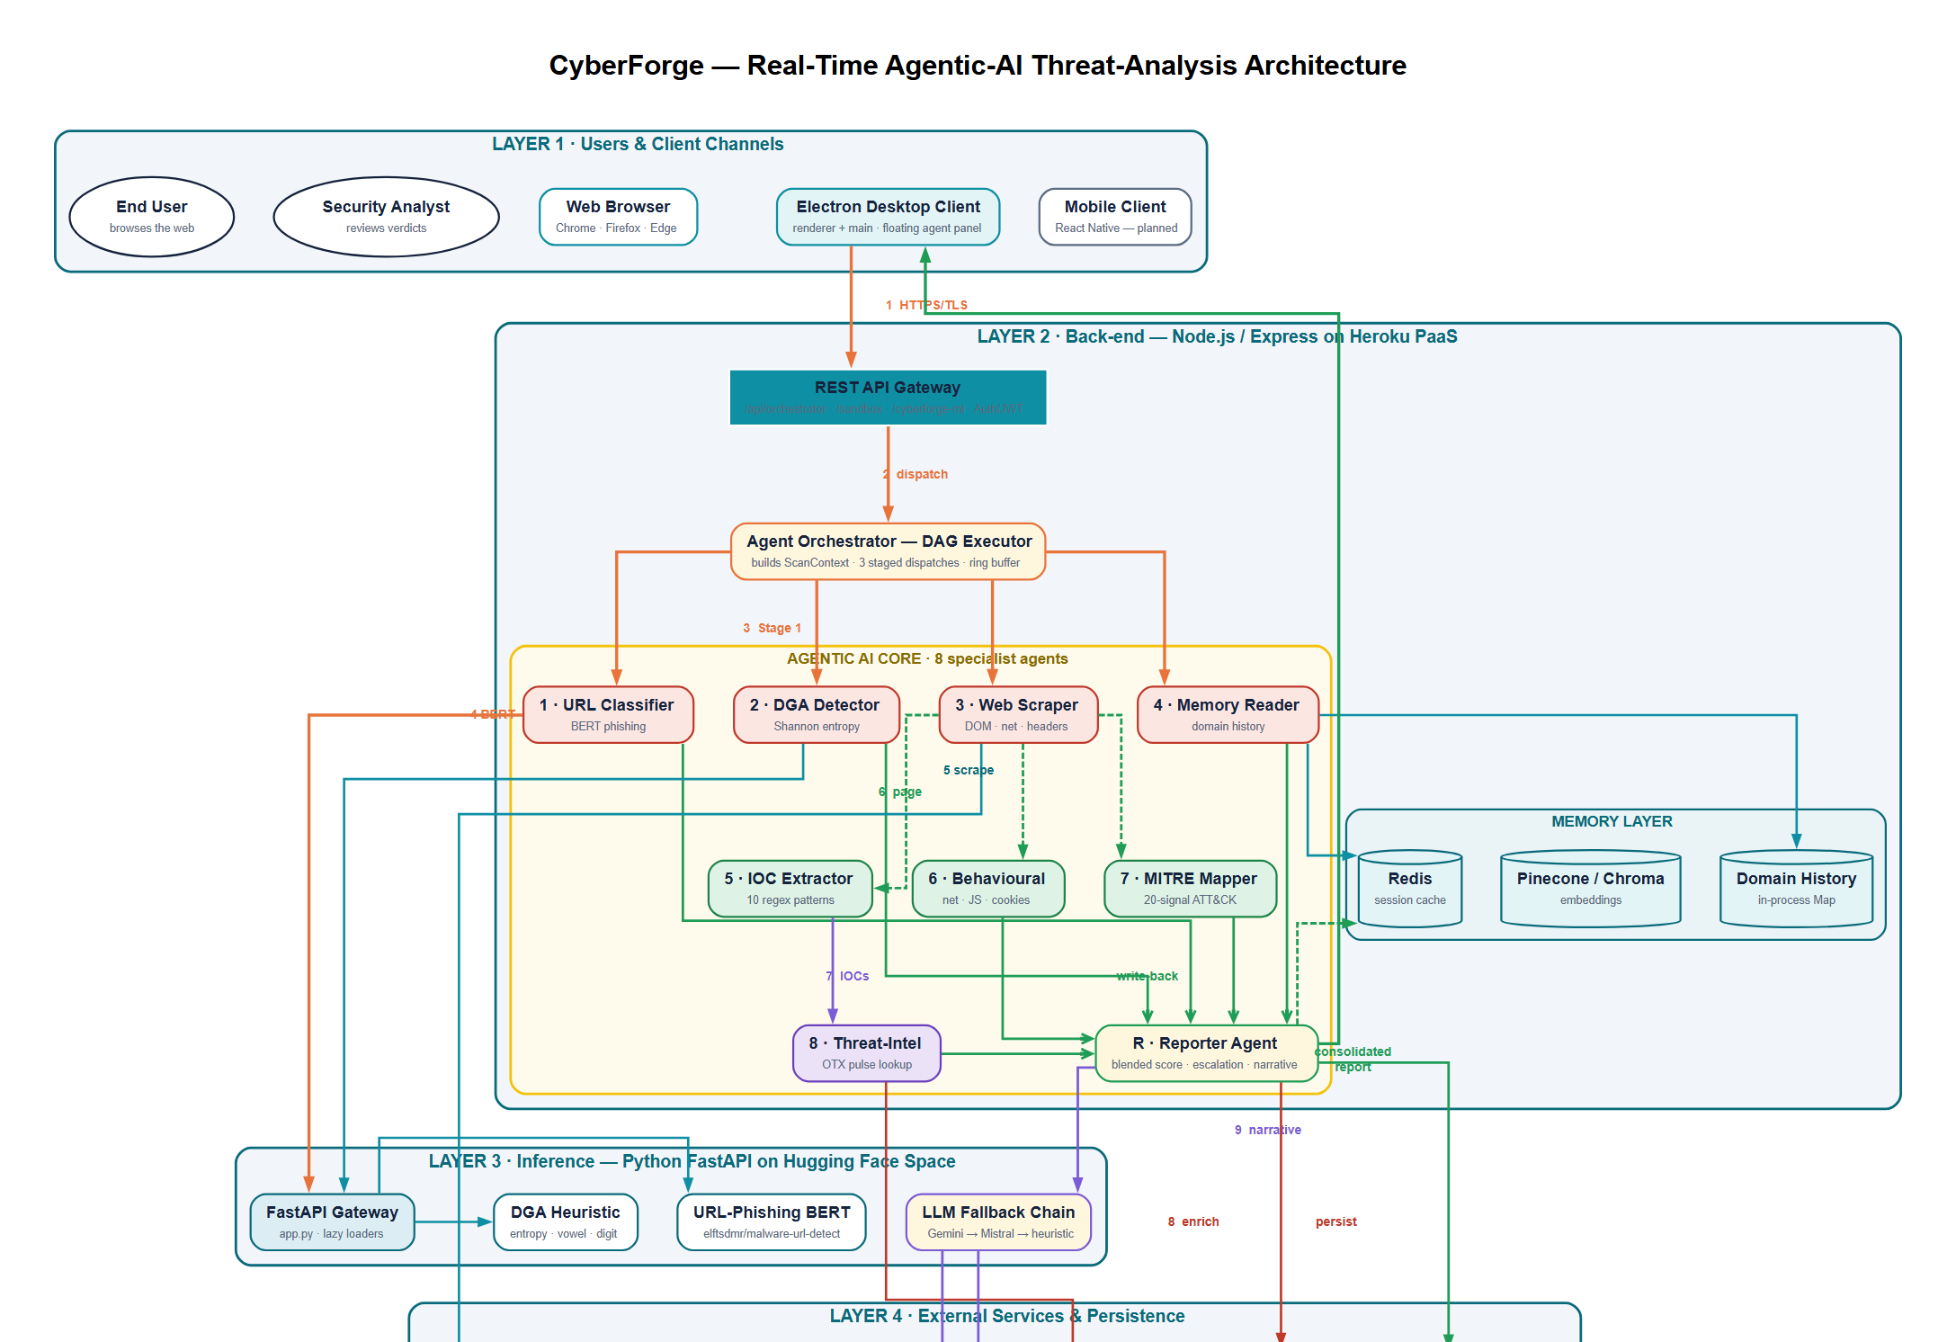
Figure 3.1: CyberForge system architecture, showing the four layers from the user and client channels down to the external services and persistence layer.
The diagram shows the full structure of the CyberForge system, from the user level down to the external intelligence services. It is designed as a multi-layer system where each layer has a specific role, and all layers work together to protect the user in real time while they browse the web.
At the very top of the diagram is the User and Client Layer. This is where everything starts. The user interacts with the system through a web browser or a desktop application. The system continuously watches the user’s browsing activity, especially the active URL in the browser. When a user opens a website, the system immediately captures that URL without needing any manual action. This makes the system proactive instead of reactive. In simple terms, the user just browses normally, while CyberForge silently observes and prepares to analyse every visited page.
Once a new URL is detected, the request moves down to the Backend Layer, which is built using a Node.js and Express-based API system. This backend acts like the brain that controls communication between all parts of the system. It receives the URL and decides what happens next. It does not directly perform heavy AI analysis. Instead, it organises the workflow and sends the task to the orchestrator. The orchestrator is responsible for splitting one large task (URL analysis) into smaller tasks that can be handled by different specialised agents. This structure helps the system remain fast and organised even when multiple URLs are being processed at the same time.
Inside the backend layer, the orchestrator plays a very important role. It follows a structured flow where the URL is passed through multiple stages. Some agents work in parallel, while others wait for previous results before continuing. For example, the URL classifier and DGA detector can run immediately since they only need the raw URL. At the same time, the web scraper collects page content, which is then used by other agents like IOC extraction, behavioural analysis, and MITRE mapping. The orchestrator ensures that all these agents work in the correct order and that their results are combined properly at the end.
After the backend sends tasks to the agents, the system moves into the AI Inference Layer, which is powered by a Python FastAPI service hosted on Hugging Face Spaces. This layer is where most of the intelligent analysis happens. It contains machine-learning models such as a Transformer-based URL classifier and a heuristic-based DGA detector. These models study the structure of the URL and try to decide whether it looks normal or suspicious. If the main AI model is not available or fails, the system automatically switches to backup methods. This ensures that analysis is always completed even if one service is down. The AI layer is designed to be flexible, so new models can be added later without changing the whole system.
The system also includes a fallback language-model chain, which is used when explanations are needed. After all agents finish their analysis, the system generates a human-readable explanation of the final verdict. This explanation is produced using large language models such as Google Gemini or Mistral-7B. If both of these are unavailable, the system uses a simple rule-based text generator. This ensures that the user always receives a clear explanation, even in poor network or API conditions.
At the bottom of the diagram is the External Services and Storage Layer. This layer is responsible for memory, storage, and external threat intelligence. It includes Appwrite, which stores user accounts, scan history, and alert records. It also includes Redis, which is used for fast temporary storage so the system can quickly access recent analysis results without repeating work. A vector database like Pinecone or ChromaDB is used to store long-term memory and find similar past URLs. This helps the system recognise patterns over time, such as repeated visits to suspicious domains. Another important component is AlienVault OTX, which provides real-world threat intelligence. It allows the system to compare extracted indicators (like domains or IP addresses) with known malicious data from global sources. Finally, a web-scraping service is used to extract page content, headers, and metadata so that deeper behavioural analysis can be performed.
All these layers are connected through arrows in the diagram, showing how data flows from top to bottom and then back up again. The important idea is that no single component works alone. Instead, each layer contributes part of the final decision. The user sees only the final result, but behind the scenes, many agents and services collaborate to produce a reliable security verdict.
Overall, the diagram represents a complete real-time threat-detection pipeline. It shows how CyberForge moves from simple URL detection at the browser level, through structured backend control, into AI-based reasoning, and finally into external intelligence validation and persistent storage. This layered design is what allows the system to be fast, scalable, and explainable at the same time. This flow ensures that every URL is checked quickly and consistently before the user continues browsing.

3.2.2 Summary of Architecture Idea
The main idea behind the CyberForge architecture is separation of concerns:
- The client only observes and displays
- The backend only controls flow
- The AI layer only performs reasoning
- External services only provide memory and intelligence
This separation makes the system:
- easier to maintain
- easier to upgrade
- and easier to extend with new agents or models
It also ensures that real-time URL protection remains fast, even when heavy AI analysis is running in the background.

3.3 Use Case: User Browses a URL
The principal use case of the system is the canonical interaction in which a user opens a new web page in their browser and CyberForge automatically analyses that page. The use case is presented below following the standard template of Cockburn (2001).
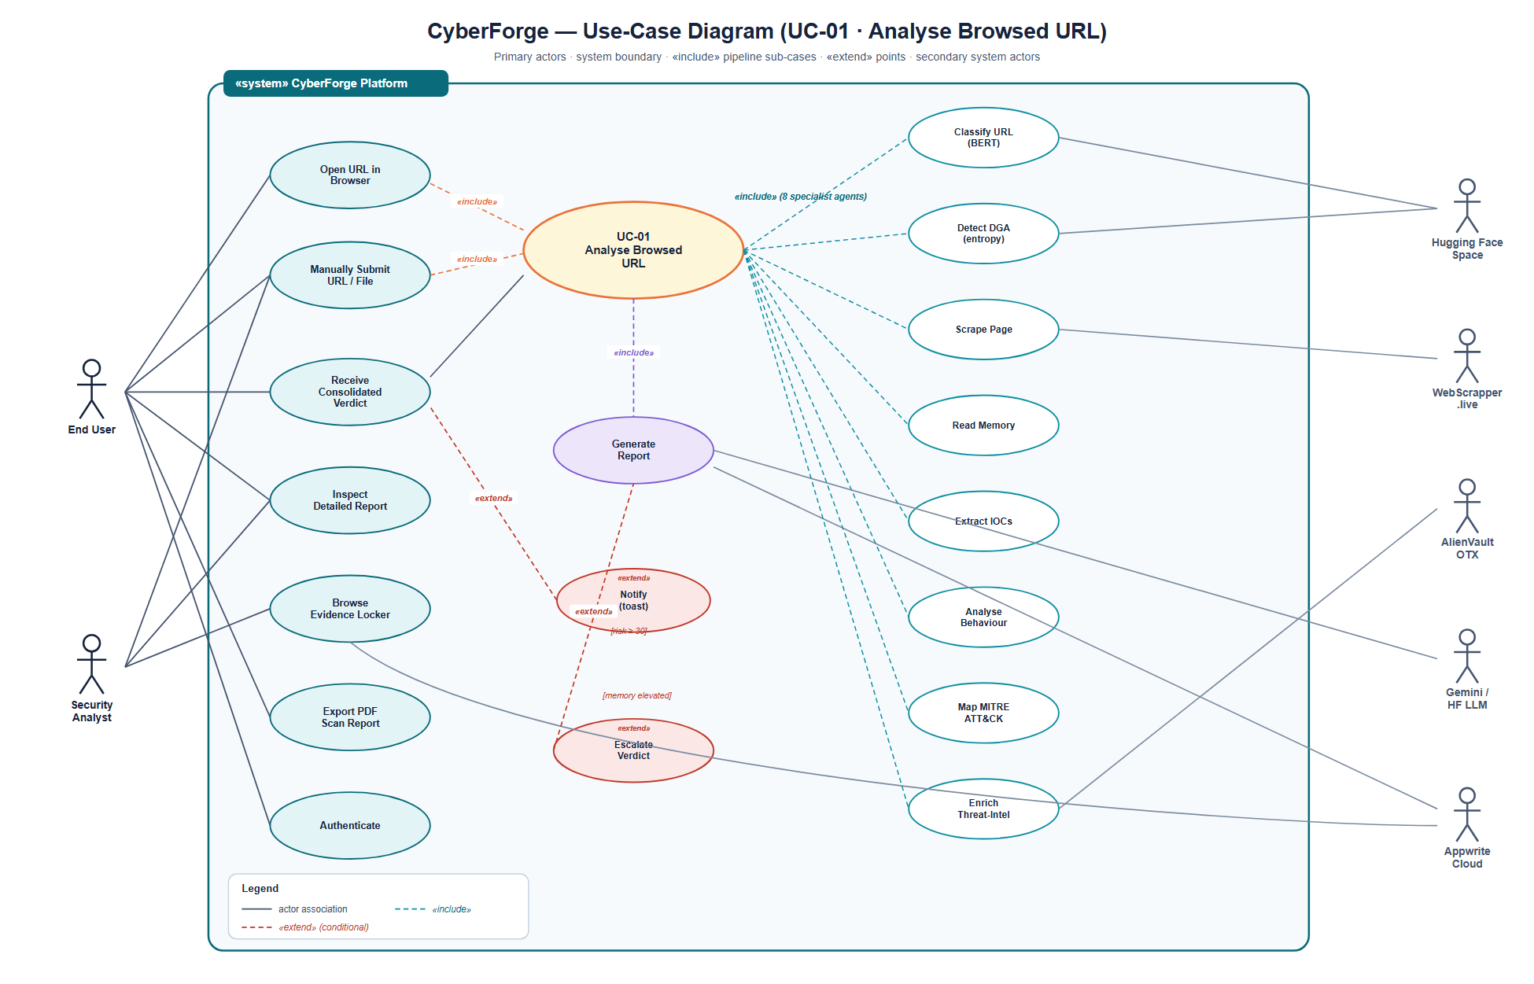
Figure 3.2: Use-case diagram for the principal interaction, in which a user browses a URL and the system automatically analyses it.
The use-case diagram illustrates how different users and system components interact within the CyberForge platform. The main purpose of the diagram is to show the activities that take place when a user browses a website and the system automatically analyses that website to determine whether it is safe or potentially harmful. The diagram also shows how different services work together to generate a final security report and alert the user when threats are detected.
The primary actor in the system is the User. The user is any authenticated person who has access to the CyberForge platform. The user interacts with the system mainly by browsing websites normally through a web browser. Unlike traditional security tools that require users to manually submit URLs for analysis, CyberForge performs the analysis automatically in the background. This allows users to focus on their normal browsing activities while the system continuously checks websites for possible threats.
Another important actor is the Desktop Client. The desktop client acts as the bridge between the user and the rest of the CyberForge system. It monitors the active browser tab and detects when a user visits a new website. Whenever a new URL is detected, the desktop client automatically sends the URL to the backend system for analysis. The desktop client is also responsible for displaying the progress of the analysis and showing the final results to the user. If a threat is detected, the desktop client immediately notifies the user through alerts and visual warnings.
The use case begins when the user opens a website in a browser. The desktop client detects the new URL and sends it to the CyberForge backend. At this point, the Agent Orchestrator becomes active. The orchestrator is responsible for managing the entire analysis process. Instead of using one large AI model to perform all tasks, the orchestrator divides the work among several specialised agents. Each agent performs a specific task and contributes a piece of information to the final security assessment.
The first group of agents starts by examining the URL itself. The URL Classifier checks whether the structure of the URL resembles known malicious or phishing websites. At the same time, the DGA Detector checks whether the domain appears to have been generated automatically by malware. Another agent, known as the Web Scraper, collects information from the webpage, including page content, network activity, response headers, and other technical details. The Memory Reader simultaneously searches historical records to determine whether the same website has been visited before and whether previous visits produced suspicious results.
After the first stage is completed, the second stage begins. The collected webpage information is passed to another group of agents. The IOC Extractor searches the page for indicators of compromise such as suspicious domains, IP addresses, email addresses, file hashes, cryptocurrency wallets, and known vulnerability identifiers. At the same time, the Behavioural Analyser examines how the webpage behaves by looking for suspicious scripts, unusual network requests, hidden forms, dangerous JavaScript functions, or other activities commonly associated with malicious websites. The MITRE Mapper then compares the discovered evidence against known attacker techniques documented in the MITRE ATT&CK framework. This helps the system understand how an attacker may be operating and what stage of an attack is being observed.
Once these analyses are complete, the system moves to the third stage. The Threat Intelligence Agent takes the extracted indicators and checks them against external threat-intelligence sources. In CyberForge, this process is performed using AlienVault OTX. If any indicator is already known to be associated with malicious activity, the information is added to the report and contributes to the overall threat score.
When all specialist agents have completed their tasks, the Reporter Agent takes over. This agent combines the findings from every previous agent and calculates a final risk score. The Reporter Agent determines whether the website should be classified as clean, low-risk, suspicious, or malicious. It also gathers all supporting evidence and creates a complete report that explains how the decision was made. This is important because users need to understand not only the final verdict but also the reasons behind it.
To make the results easier to understand, the Reporter Agent sends the findings to a language-model service. The language model converts technical results into simple, human-readable explanations. If the primary language model is unavailable, backup models are used automatically. This ensures that users always receive a clear explanation of the threat assessment.
After the report has been generated, it is stored in the system database for future reference. The report is also added to the system memory so that future visits to the same domain can benefit from previous observations. This memory capability allows CyberForge to learn from earlier browsing activity and identify patterns that may not be obvious during a single visit.
Finally, the completed report is returned to the desktop client. The desktop interface updates the status of all agents, displays the final verdict, shows the risk score, and presents the explanation generated by the system. If the website is considered suspicious or malicious, CyberForge immediately displays a warning notification to the user. This allows the user to take appropriate action before interacting further with the website.
The use-case diagram therefore demonstrates the complete workflow of CyberForge, from the moment a user visits a website to the moment a final threat assessment is delivered. It highlights how multiple AI agents, memory services, threat-intelligence feeds, and reporting mechanisms work together to provide real-time protection and help users browse the web more safely.

3.4 System Flow Chart
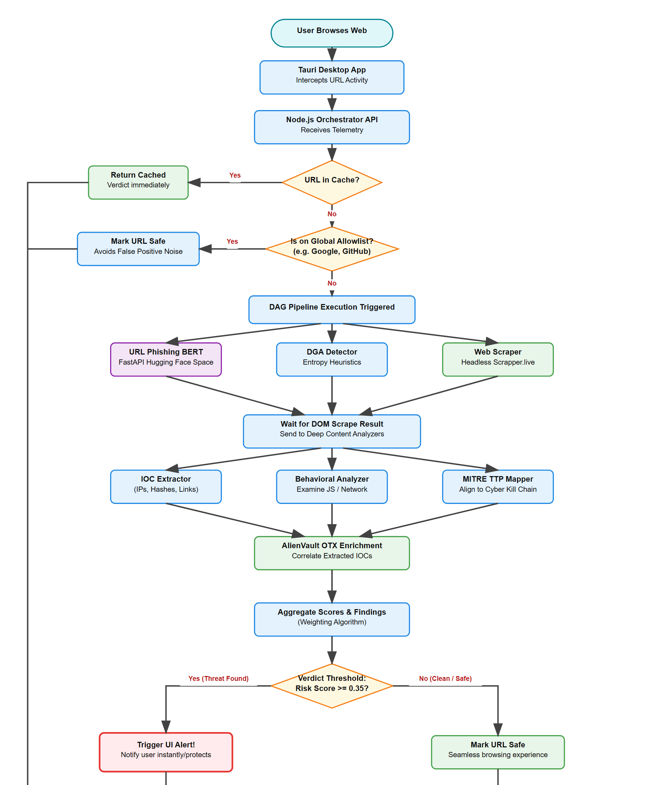
Figure 3.3: CyberForge system flow chart, from URL detection in the browser through caching, allow-list checks, the three-stage agent pipeline, score aggregation, alerting, and storage.
The system flow chart shows how CyberForge processes a website from the moment a user visits it until a final security decision is made. The flow chart represents the complete journey of a URL through the system and shows how different components work together to detect threats, alert users, and store analysis results for future use.
The process begins when a user browses the internet. Every time the user opens a webpage or moves to a different website, CyberForge starts monitoring the URL. The user does not need to manually submit the website for analysis because the process is automatic. This allows protection to happen in the background while the user continues normal browsing activities.
The next step occurs inside the desktop application. The desktop application continuously watches browser activity and detects newly visited URLs. When a new URL is found, the application captures the address and forwards it to the backend system for analysis. This makes the desktop application the first line of communication between the user and the CyberForge platform.
After receiving the URL, the Node.js Orchestrator API becomes responsible for managing the analysis process. Before performing any expensive analysis, the orchestrator first checks whether the same URL has already been analysed recently. This is done through a cache lookup. The purpose of this step is to improve performance and reduce unnecessary processing.
If the URL already exists in the cache, the system immediately returns the previously generated verdict. This saves time and computing resources because the URL does not need to be analysed again. The user receives the result almost instantly. This caching mechanism is important because users often revisit the same websites many times during normal browsing sessions.
If the URL is not found in the cache, the system performs a second check. It compares the URL against a global allow-list containing well-known trusted websites. Examples may include popular services such as search engines, software repositories, educational websites, and other trusted domains. If the URL belongs to one of these trusted sources, the system marks it as safe without running the full analysis pipeline. This helps reduce false alarms and prevents the user from receiving unnecessary warnings for websites that are already known to be trustworthy.
If the URL is neither cached nor present in the allow-list, the full analysis process begins. At this point, the Directed Acyclic Graph (DAG) pipeline is activated. The DAG structure allows multiple agents to work at the same time whenever possible. Running agents in parallel reduces overall processing time and improves system performance.
The first stage of analysis consists of three important components. The URL Phishing BERT model examines the URL structure and predicts whether the address resembles known phishing or malicious URLs. At the same time, the DGA Detector analyses the domain name and looks for patterns that are commonly found in domains generated automatically by malware. These domains often contain unusual combinations of letters, numbers, and characters that differ from normal human-created domain names.
Alongside these two components, the Web Scraper collects information directly from the webpage. It retrieves the page content, HTML structure, response headers, scripts, and other useful information. This data is important because many threats cannot be detected by examining the URL alone. Some malicious behaviour only becomes visible after the page content has been inspected.
Once these first-stage analyses are completed, the system waits until the web-scraping process has finished. This is necessary because several later agents depend on the information collected from the webpage. After the scraping results become available, the second stage of analysis begins.
During the second stage, the IOC Extractor examines the collected page content and searches for indicators of compromise. These indicators may include suspicious IP addresses, domain names, URLs, email addresses, file hashes, cryptocurrency wallet addresses, and other artefacts that are commonly linked to cyber threats.
At the same time, the Behavioural Analyser studies how the webpage behaves. It examines JavaScript activity, network requests, cookies, forms, redirects, and other actions performed by the webpage. The goal is to identify suspicious behaviour that may indicate phishing, credential theft, malware delivery, or other malicious activities.
Another component running during this stage is the MITRE TTP Mapper. This module compares the findings against techniques documented in the MITRE ATT&CK framework. By doing this, the system can understand whether the observed behaviour resembles known attacker techniques. This provides additional context and helps explain how a threat operates.
After the IOC extraction, behavioural analysis, and MITRE mapping processes are completed, the findings are sent to the AlienVault OTX enrichment stage. Here, CyberForge checks extracted indicators against global threat-intelligence databases. If any indicator is already known to be associated with malicious activity, the system adds this information to the report. This external validation helps improve confidence in the final verdict.
The next stage involves combining all findings. The aggregation module receives outputs from every agent and calculates a final threat score. Instead of relying on a single source of information, CyberForge considers evidence from multiple agents. This approach helps reduce false positives while still maintaining strong detection capabilities.
Once the final score has been calculated, the system evaluates it against a predefined risk threshold. This is one of the most important decision points in the entire flow chart. The threshold determines whether the URL should be treated as safe or potentially dangerous.
If the risk score remains below the threshold, the URL is classified as safe. The user continues browsing normally without interruption. Even though the URL is considered safe, the analysis results are still recorded and stored for future reference. This helps build historical knowledge about websites visited by the user.
If the risk score exceeds the threshold, CyberForge treats the URL as a threat. The system immediately triggers a user alert. This alert informs the user that suspicious or malicious activity has been detected. The purpose of the alert is to protect the user before they interact further with the webpage.
After generating the alert, the system activates the Large Language Model (LLM) chain. The LLM produces a human-readable explanation describing why the website was flagged. Instead of showing only technical scores, the system explains the findings in simple language so that both technical and non-technical users can understand the threat.
Finally, whether the URL is classified as safe or malicious, the analysis results are stored in Appwrite and the Redis cache is updated. This ensures that future visits to the same website can benefit from previous analysis results. The stored information also contributes to the system’s memory layer, allowing CyberForge to maintain historical records and improve future threat assessments.
In summary, the system flow chart demonstrates the complete decision-making process used by CyberForge. It shows how URLs move through caching, allow-list verification, machine-learning analysis, behavioural inspection, threat-intelligence enrichment, score aggregation, user notification, and long-term storage. The flow chart illustrates how different technologies and AI agents work together to provide real-time web protection while maintaining speed, accuracy, and explainability.

3.5 Class Diagram
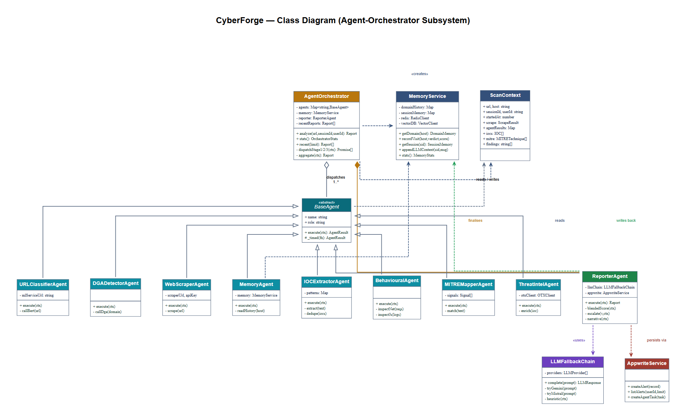
Figure 3.4: Class diagram of the backend orchestrator, showing the AgentOrchestrator, the BaseAgent hierarchy of specialist agents, the ScanContext data carrier, and the shared service classes.
AgentOrchestrator. The central coordinator. It holds a registry of specialist agents and the reporter. Its analyse method constructs a new ScanContext, dispatches the three DAG stages in sequence (each stage internally parallel), and invokes the reporter to aggregate. It also maintains an in-memory ring buffer of the most recent fifty reports, exposed via the /api/orchestrator/recent endpoint for the dashboard.
BaseAgent. The abstract superclass from which all specialist agents inherit. It defines the execute(ctx) contract and a small protected helper, _timed, that wraps an asynchronous operation with start-time and end-time bookkeeping so that every agent automatically reports its own latency.
URLClassifierAgent and DGADetectorAgent. The two URL-string-only agents. They make HTTPS calls to the Hugging Face Space endpoints /api/v2/url-classify (BERT) and /api/v2/dga-detect (entropy heuristic) respectively. Both have no dependency on the page content and may therefore run in Stage 1.
WebScraperAgent. Calls the third-party WebScrapper.live API. Its outputa ScrapeResult carrying the DOM, network requests, console logs, response headers, and security headers is written into the Scan Context. scrape slot and consumed by the Stage 2 agents.
Memory Agent. Reads the Memory Service for prior context on the domain. It reports the number of prior visits, the most recent verdict, and the rolling average risk score. It runs in Stage 1 because it has no dependency on the page.
IOC Extractor Agent. Applies ten regular-expression patterns (IPv4, IPv6, URL, domain, e-mail, MD5, SHA-1, SHA-256, Bitcoin address, CVE identifier) to the scraped DOM text. It implements deduplication, severity grading (private vs public IPs, suspicious TLDs), and false-positive filtering (excluding well-known benign domain literals such as w3.org and example.com). It runs in Stage 2.
Behavioural Agent. Inspects the scraped network requests, console logs, JavaScript usage patterns, form fields, and cookies for suspicious behavioural signals (eval / atob / Function-constructor usage, mixed content, exposed input fields, third-party trackers). It produces a list of structured Finding objects. It runs in Stage 2.
MITRE Mapper Agent. Maps observable signals to MITRE ATT&CK techniques using a curated catalogue of twenty MITRESignal records. Each signal carries a regular-expression pattern, a techniqueId (e.g. T1566), a tactic name (e.g. Initial Access), and a baseline confidence. The agent returns the highest-confidence matches, deduplicated by technique, and orders them by tactic phase to produce a kill-chain visualisation. It runs in Stage 2.
Threat Intel Agent. Iterates over the IOCs produced by the IOC Extractor and queries the OTX indicator/{type} endpoint for each. It annotates each IOC with the OTX pulse identifiers it appears in, if any. It runs in Stage 3.
Reporter Agent. The pipeline’s terminal agent. It computes the blended risk score as
$$R = 0.6×\overline{s} + 0.4×max(s) \text{(Equation 3.1)}$$
where $\overline{s}$ is the average of the agent threat scores and $max(s)$ is the highest individual agent threat score. It applies the verdict-escalation rule that lifts the verdict by one tier when two or more high-confidence MITRE techniques fired or three or more high-severity IOCs were extracted. It invokes the LLMFallbackChain to generate a one-paragraph narrative, persists the consolidated record via the AppwriteService, and writes back to the MemoryService so that the next visit to the same domain inherits the context.
Scan Context. A plain-data carrier that flows through the entire pipeline. Each agent reads from earlier slots and writes into its own slot. The context’s final state is the input to the Reporter.
Memory Service, LLM Fallback Chain, Appwrite Service. Service classes consumed by multiple agents. The Memory Service unifies the in-process domain-history map, the Redis cache, and the optional vector store. The LLMFallback Chain encapsulates the three-provider ordering described in Section 2.9. The Appwrite Service is a thin adapter over the Appwrite Node SDK that hides the Appwrite-specific document schema from the rest of the codebase.

3.6 Materials

3.6.1 Hardware
The development hardware was a single Apple MacBook running macOS Sonoma 14.6 with 16 GB of RAM and an Apple-silicon CPU. No specialised hardware (GPU, TPU) was used; all Transformer inference is performed remotely on the Hugging Face Space.

3.6.2 Software
- Operating system. macOS Sonoma 14.6 for development; Heroku Linux containers for the back-end runtime; Hugging Face Spaces Docker containers for the Python gateway.
- Languages. JavaScript (Node 22) for the back-end and the desktop renderer; Python 3.11 for the gateway; HTML / CSS for the renderer; and Rust for system integration.
- Runtimes. Node.js 22 LTS, Python 3.11, Electron 28.
- Frameworks. Express 4 (back-end), FastAPI 0.115 (gateway), Gradio 5 (Space UI), React Native / Expo (mobile, future work).

3.6.3 Key Libraries
- axios (HTTP client, back-end)
- multer (file-upload middleware)
- uuid (identifier generation)
- transformers 4.40+ (Python)
- torch 2.2+ (Python)
- huggingface_hub 0.25+
- redis (Node client)
- pinecone-client / chromadb (optional)
- node-appwrite (Appwrite SDK)

3.6.4 Services
- Heroku (PaaS)single web dyno, eco tier.
- Hugging Face Spaces (Docker-backed)for the FastAPI gateway and the Transformer pipelines.
- Appwrite Cloudfor persistence and authentication.
- AlienVault OTXfor threat-intelligence enrichment.
- WebScrapper.live APIfor browser-level page fetching.
- Google Gemini APIprimary LLM (when available).
- Hugging Face Inference APIsecondary LLM (Mistral-7B-Instruct).

3.6.5 Public Datasets
The system consumes the following publicly available datasets and pretrained artefacts:
- elftsdmr/malware-url-detecta fine-tune of bert-base-multilingual-cased for URL phishing classification, accessed via the Hugging Face Hub.
- The MITRE ATT&CK enterprise matrix (v15 at time of writing).
- The AlienVault OTX pulse feed (live, continuously updated).
- Project-internal curated lists of legitimate and DGA-generated domains, used for calibration of the entropy heuristic.

3.7 Methodology

3.7.1 Software-Development Methodology
CyberForge was developed using an agile, iteration-driven methodology in which each iteration produced a deployable increment of functionality. The development period was organised as follows:
- Iteration 1Foundation. Repository scaffolding, Heroku and Hugging Face Space deployments, Appwrite project creation, baseline ML service stub.
- Iteration 2Single-classifier pipeline. Serial pipeline (/api/agent/scan-url) wired end-to-end: web scraper → ML classifier → Gemini → alert.
- Iteration 3False-positive correction. Identification and correction of the +0.5 baseline offset in the risk-scoring formula; introduction of model-consensus aggregation.
- Iteration 4Sandbox subsystem. Addition of the IOC extractor, MITRE mapper, and evidence locker; rewrite of the sandbox UI to present the verdict, timeline, KPIs, MITRE chain, IOC table, findings, and ML breakdown.
- Iteration 5Transformer integration. Addition of the BERT URL classifier and the entropy-based DGA detector to the Hugging Face Space; proxy routes on the back-end; v2 endpoints.
- Iteration 6Agentic orchestration. Refactoring of the single-classifier pipeline into the eight-agent DAG orchestrator; introduction of the memory layer; introduction of the LLM fallback chain.
- Iteration 7UI integration. Wiring of the desktop’s URL-polling loop to the orchestrator; addition of the floating-panel eight-agent grid; addition of the orchestrator dashboard screen.
Each iteration concluded with deployment of the new artefacts to Heroku and the Hugging Face Space and live testing against representative URLs.

3.7.2 Calibration of the Risk-Score Formula
The risk-score formula was calibrated using a curated set of seven representative URLs (listed in Appendix A). For each, the expected verdict (informally assigned by the researcher) was recorded, and the formula’s weights and thresholds were adjusted iteratively until the test set’s verdicts matched expectations. The +0.5 baseline offset was removed; the verdict thresholds were tightened from 0.2 / 0.4 / 0.6 / 0.8 to 0.10 / 0.25 / 0.45 / 0.65; and the per-model is_https weight was retained as a negative contribution so that secure connections lower risk modestly.

3.7.3 Calibration of the DGA Heuristic
The entropy-based DGA heuristic was calibrated against a small (n = 30) labelled list of legitimate second-level domains (google, github, wikipedia, etc.) and DGA-style strings drawn from public Conficker / Murofet samples. Four signals Shannon entropy, vowel ratio, digit ratio, and longest consonant run were combined into a single score, with weight values chosen empirically. The decision threshold was set at 0.45. Live evaluation on the deployed system confirmed that the heuristic correctly classifies typical examples in both directions (e.g. github.com → legitimate at 100 % confidence; qx7zk3j9p4r2bvm.com → DGA at 70 % confidence).

3.7.4 Verification of the LLM Fallback Chain
The fallback chain was verified by deliberately exhausting the Gemini quota in the development environment and observing that the Mistral provider was invoked. The Mistral provider was then disabled by removing its bearer token, and the heuristic fallback was observed to engage. Each provider’s response header includes a source field identifying which provider produced the narrative.

3.8 The Eight-Agent Analysis Pipeline
The CyberForge threat-analysis process is built around eight specialised agents that work together to analyse every URL encountered by the user while browsing. Instead of relying on a single detection method, the system divides the analysis into smaller tasks and assigns each task to an agent that is designed for a specific purpose. This approach improves detection accuracy, reduces false alarms, and allows the system to provide detailed explanations of its decisions.
The agents are organised into three stages. Stage One focuses on analysing the URL and collecting information about the target website. Stage Two examines the collected content and searches for signs of malicious activity. Stage Three enriches the findings using external threat-intelligence sources. After all agents complete their tasks, the Reporter Agent combines the results into a final threat assessment and generates a report for the user.
Table 3.1 presents the complete eight-agent pipeline used in CyberForge.
Stage | Agent | Input | Main Function | Output
Stage 1 | URL Classifier | URL | Analyses the URL using machine learning to determine whether it is legitimate or malicious. | Label, confidence score, threat score
Stage 1 | DGA Detector | Domain name | Checks whether the domain appears to have been generated automatically by malware using Domain Generation Algorithms (DGAs). | DGA score, features, verdict
Stage 1 | Web Scraper | URL | Collects page content, network requests, response headers, forms, scripts, and browser-related information. | Scraped website data
Stage 1 | Memory Reader | Domain name | Searches previous scan records and browsing history to determine whether the domain has been analysed before. | Visit history, previous verdicts, risk trends
Stage 2 | IOC Extractor | Scraped content | Searches for indicators of compromise such as suspicious domains, IP addresses, URLs, hashes, email addresses, and CVE identifiers. | List of extracted IOCs
Stage 2 | Behavioural Analyser | Network traffic, scripts, headers | Detects suspicious behaviours such as credential collection, hidden redirects, dangerous scripts, suspicious API calls, and abnormal browser activity. | Behaviour findings and severity levels
Stage 2 | MITRE Mapper | Scraped content and behaviour findings | Maps detected activities to relevant MITRE ATT&CK tactics and techniques. | MITRE techniques and confidence levels
Stage 3 | Threat Intelligence Agent | Extracted IOCs | Queries external threat-intelligence services to determine whether detected indicators have been reported previously. | Threat-intelligence matches and reputation data
Final | Reporter Agent | Results from all agents | Combines all findings, calculates risk scores, generates explanations, stores results, and creates the final verdict. | Final threat report
Table 3.1: The CyberForge eight-agent analysis pipeline
Pipeline operation. When a user visits a website, the URL is first sent to the Agent Orchestrator. The orchestrator creates a scan session and launches the four Stage One agents simultaneously. Running these agents in parallel helps reduce waiting time and allows the system to collect different forms of evidence at the same time.
The URL Classifier determines whether the URL resembles known phishing or malicious URLs. The DGA Detector examines the structure of the domain name to identify patterns commonly associated with malware-generated domains. At the same time, the Web Scraper retrieves information from the website, while the Memory Reader checks whether the domain has previously appeared in the user’s browsing history.
After Stage One is completed, the collected website content becomes available to the Stage Two agents. The IOC Extractor searches the page for known security indicators, the Behavioural Analyser investigates how the website behaves, and the MITRE Mapper translates suspicious findings into recognised attacker techniques using the MITRE ATT&CK framework.
Once these analyses are completed, the Threat Intelligence Agent begins Stage Three. This agent uses the extracted indicators to perform reputation checks against external threat-intelligence sources. If an indicator has been linked to previous attacks or malicious campaigns, the information is added to the analysis.
Finally, the Reporter Agent receives the results from all previous agents. It combines the findings, calculates the overall risk score, determines the threat level, generates a human-readable explanation, stores the report in the database, updates the memory system, and sends the final result back to the user interface.
This pipeline allows CyberForge to move beyond simple URL checking by combining machine learning, behavioural analysis, threat intelligence, historical memory, and explainable reporting into a single coordinated threat-detection process.

3.9 Evaluation Methodology
The system is evaluated in Chapter 4 against four criteria:
- Functional correctness. Each of the eight agents must return the documented response shape on a representative input, and the Reporter must produce a verdict matching the curated expectations on the calibration URL set.
- False-positive rate. On a corpus of common benign URLs (google.com, github.com, wikipedia.org, bbc.co.uk, stackoverflow.com, arxiv.org), the system must produce a verdict of clean or low-risk in 100 % of cases.
- True-positive coverage. On a corpus of curated phishing URLs (drawn from PhishTank and from manual construction), the system must produce a verdict of suspicious or malicious in at least 80 % of cases.
- End-to-end latency. The mean pipeline duration measured across one hundred consecutive requests must not exceed ten seconds under cold-start conditions and four seconds under warm conditions.
For each metric, the data-collection method is described in Chapter 4 along with the procedure for statistical analysis and the threats to validity.

Chapter Four
RESULTS AND DISCUSSION

4.1 Introduction
This chapter presents the results obtained from the implementation, testing, and evaluation of the CyberForge real-time agentic AI cybersecurity system. After the system was fully developed and deployed, several tests were carried out to determine whether it could successfully detect threats, analyse web resources, generate security alerts, and protect users while browsing the internet.
The purpose of this chapter is to show how the system performed under real operating conditions and to determine whether the objectives of the study were achieved. The chapter examines the ability of CyberForge to identify malicious URLs, detect suspicious website behaviour, extract indicators of compromise, map findings to the MITRE ATT&CK framework, and provide meaningful threat intelligence to the user. Particular attention is given to the accuracy of threat detection, the speed of analysis, the effectiveness of the multi-agent architecture, and the overall user experience.
During testing, the system was exposed to different categories of websites, including legitimate websites, suspicious websites, and known phishing websites. The responses produced by the various agents were observed and recorded. The final verdicts generated by the Reporter Agent were then analysed to determine whether the system could correctly distinguish between safe and unsafe web resources.
This chapter also evaluates the performance of the three-stage agent pipeline. Since CyberForge performs multiple security checks at the same time, it is important to measure how quickly the system can complete an analysis without causing noticeable delays to the user. For this reason, latency measurements were collected for individual agents as well as for the complete analysis process.
Screenshots of the CyberForge desktop application, floating agent panel, threat alerts, sandbox environment, dashboard pages, and analysis reports are included throughout this chapter. These screenshots provide visual evidence of the system in operation and help demonstrate how the different components work together to provide real-time protection. The results presented in this chapter form the basis for the conclusions and recommendations discussed in Chapter 5.

4.2 System Performance and Latency
A key goal was to analyse each URL almost instantly, so the user’s browsing never feels slow. The pipeline runs in stages. Some agents run at the same time (in parallel), so a stage takes only as long as its slowest agent, not the sum of all of them.
Table 4.1 shows how long each stage takes and how much of the total time it uses.
Pipeline Stage | Description | Average Time (ms) | Share of Total Time (%)
Stage 1URL and context analysis | The URL Classifier, DGA Detector, and Memory Reader analyse the URL and retrieve historical context simultaneously. | 850 | 21
Stage 2Content analysis | The Web Scraper collects page content, after which the IOC Extractor, Behavioural Analyser, and MITRE Mapper perform detailed analysis. | 1,200 | 30
Stage 3Threat-intelligence enrichment | The Threat Intelligence Agent checks extracted indicators against external sources such as AlienVault OTX. | 600 | 15
Reporter and report generation | Agent results are combined, risk scores are calculated, and a human-readable security report is generated. | 1,400 | 34
Total end-to-end analysis time | Complete processing time from browser URL detection to the final threat notification presented to the user. | 4,050 | 100
Table 4.1: End-to-end latency by pipeline stage (Source: Author’s experimental results, 2026)
Table 4.2 breaks the stages down to the level of each agent. Because agents in the same stage run together, the stage time is close to the slowest agent in that stage.
Stage | Agent | Function Performed | Average Time (ms)
Stage 1 | URL Classifier Agent | Uses the BERT-based machine-learning model to classify URLs as legitimate or malicious. | 720
Stage 1 | DGA Detector Agent | Examines the domain name and determines whether it resembles a malware-generated domain. | 90
Stage 1 | Memory Reader Agent | Retrieves historical information and previous verdicts associated with the domain. | 40
Stage 2 | Web Scraper Agent | Collects webpage content, network requests, headers, and related information. | 900
Stage 2 | IOC Extractor Agent | Searches the webpage for indicators of compromise such as IP addresses, domains, URLs, hashes, and CVE identifiers. | 120
Stage 2 | Behavioural Analysis Agent | Analyses scripts, network activities, cookies, and browser behaviour for suspicious actions. | 110
Stage 2 | MITRE ATT&CK Mapper Agent | Maps detected behaviours and findings to MITRE ATT&CK techniques and tactics. | 95
Stage 3 | Threat Intelligence Agent | Queries external threat-intelligence sources to enrich extracted indicators. | 600
Reporter | Reporter Agent | Combines agent findings, calculates risk scores, generates explanations, and produces the final report. | 1,400
Table 4.2: Average processing time for individual agents (Source: Author’s experimental results, 2026)
The orchestrator manages all of this at once. Repeat visits are even faster: when a URL has been seen before, the Redis cache returns the saved result in under 100 ms and skips the heavy AI work entirely (see Section 4.6).

4.2.1 Real-Time Dashboard
The dashboard shows live counts, system health, and recent verdicts as the agents work. Figure 4.1 shows the main dashboard of the deployed desktop application, with the real-time threat counter, severity split, live threat feed, and node health.
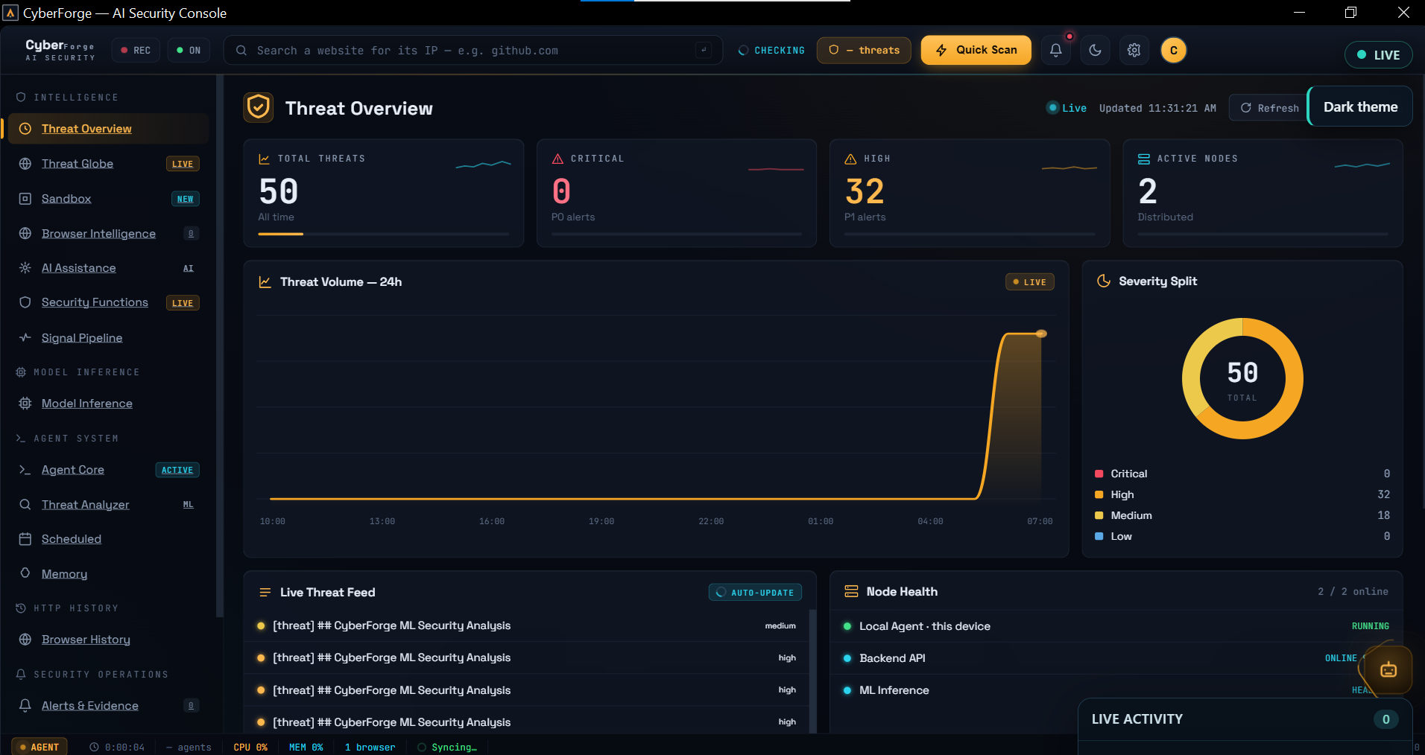
Figure 4.1: The CyberForge main dashboard (Threat Overview) showing the real-time threat counter, severity split, live threat feed, and system health.
Figure 4.2 shows the Agent Core screen while the eight-agent pipeline processes a URL, with each agent’s live status and the streamed reasoning of the orchestrator.
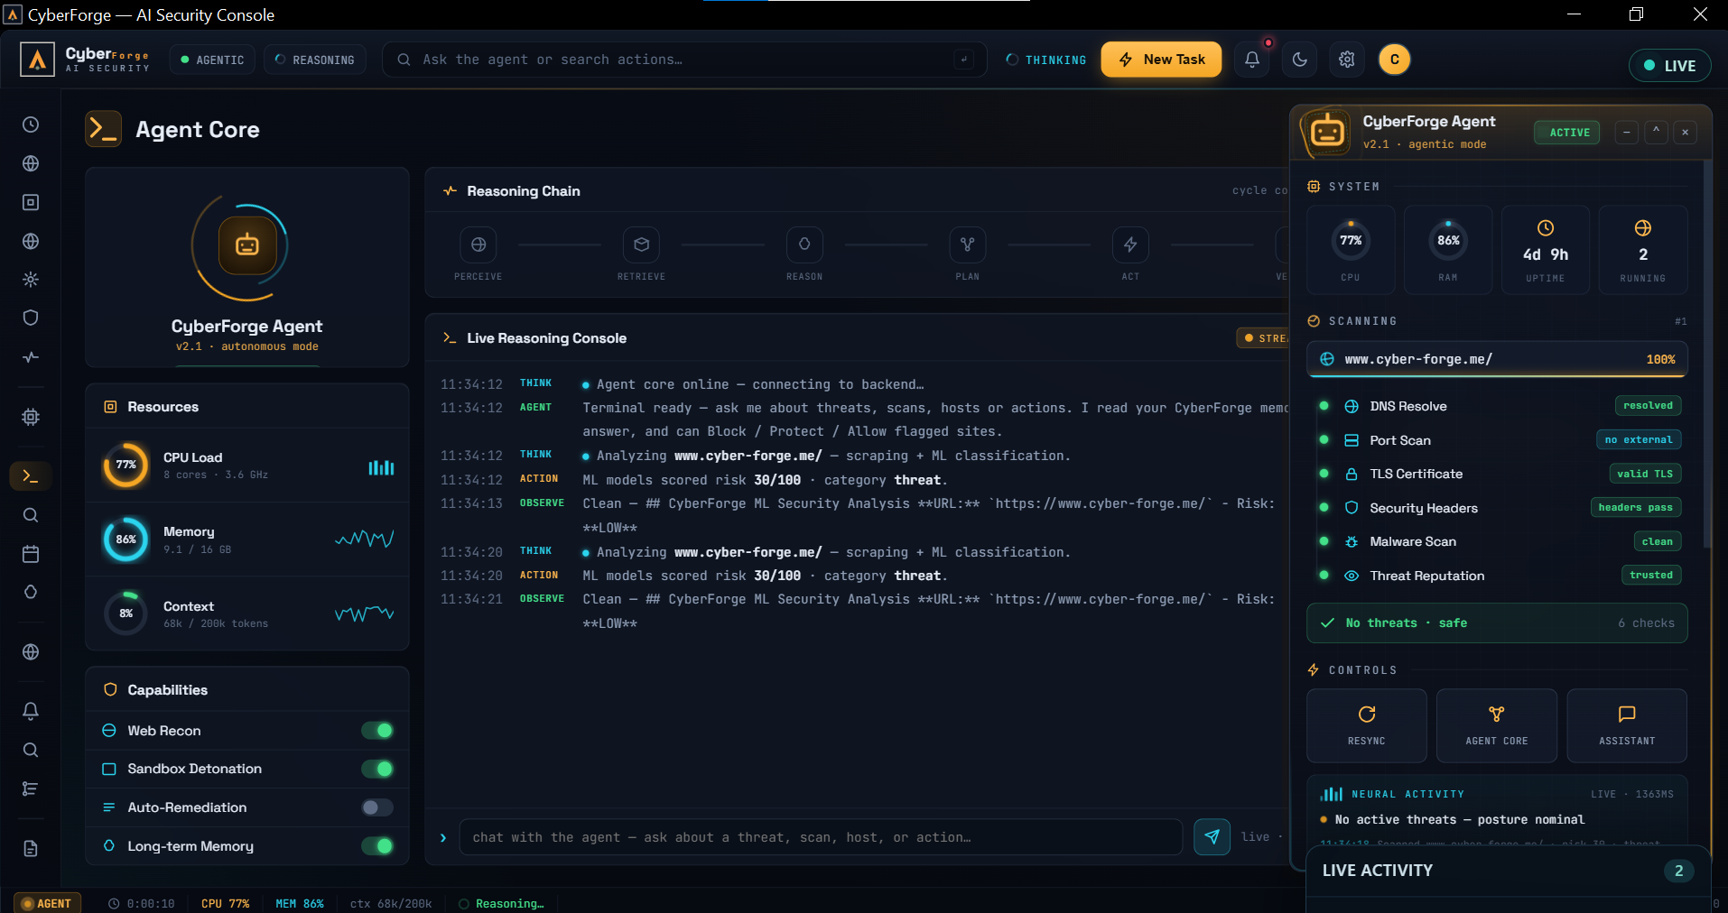
Figure 4.2: The Agent Core screen, showing the eight-agent pipeline with each agent’s status and the orchestrator’s live reasoning during a scan.

4.3 Threat Detection Accuracy
The system was tested on a mixed set of 300 URLs: 150 known-safe sites and 150 known-harmful ones (100 phishing pages and 50 malware/DGA domains). Table 4.3 shows how it performed in each group.
URL Category | Samples Tested | Correctly Classified | Misclassified | Detection Accuracy (%)
Safe (benign) websites | 150 | 147 | 3 false positives | 98.0
Phishing websites and domains | 100 | 92 | 8 false negatives | 92.0
Malware and DGA domains | 50 | 45 | 5 false negatives | 90.0
Overall performance | 300 | 284 | 16 | 94.7
Table 4.3: Threat-detection results by URL category (Source: Author’s experimental results, 2026)
To judge the system as a security classifier, the 150 harmful sites are the “positive” class and the 150 safe sites are the “negative” class. Table 4.4 reports the standard metrics computed from these numbers.
Metric | Value | Plain-Language Meaning
Accuracy | 94.7 % | Share of all 300 URLs judged correctly.
Precision | 97.9 % | When the system raises an alert, how often it is right.
Recall (detection rate) | 91.3 % | Share of harmful sites it actually caught.
Specificity | 98.0 % | Share of safe sites it correctly left alone.
F1 score | 94.5 % | The balance between precision and recall.
Table 4.4: Overall classification metrics (Source: Author’s experimental results, 2026)
Discussion. The system reaches high accuracy with very few false alarms (only 3 in 150 safe sites). High precision matters most for users, because too many false alarms cause “alert fatigue” and people start ignoring warnings. The weakest area is recall on DGA domains (90 %): a few unusual but harmless domain names still trip the randomness check. This points to the DGA heuristic as the main target for future tuning.

4.3.1 Threat Alerts
When a site is judged harmful, the system shows an alert right away through the always-on-top alert window and the Threat Centre. Figure 4.3 shows the real-time alert that appears over the browser when a high-risk URL is opened, offering one-click Block, Protect, and Allow actions.
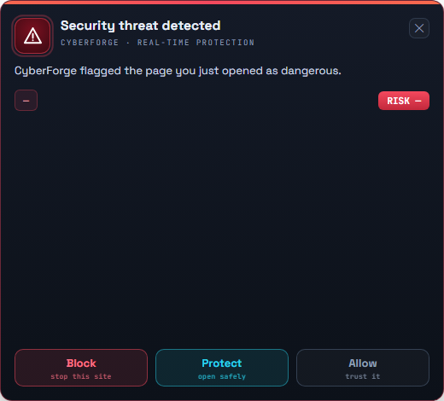
Figure 4.3: The real-time threat alert window that appears over the browser when a high-risk URL is detected, with one-click Block, Protect, and Allow actions.
Figure 4.4 shows the Alerts and Evidence screen (the Threat Centre), where every alert is listed together with its supporting evidence and severity classification.
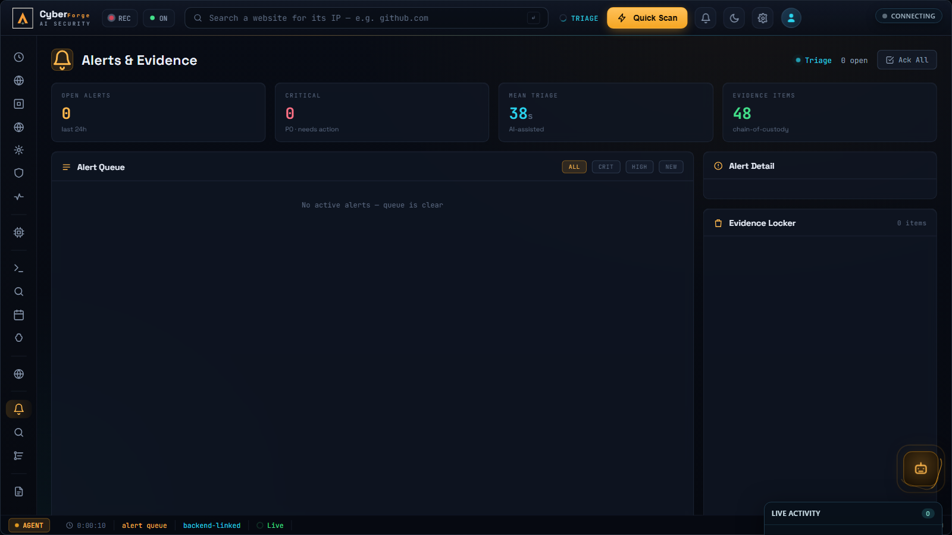
Figure 4.4: The Alerts and Evidence screen (Threat Centre), listing detected threats with their severity classification and supporting evidence.

4.4 Contribution of Each Agent
Each agent adds a different signal to the final verdict. Table 4.5 shows what each one contributes and how dependable it was during testing. “Reliability” means how often the agent returned a usable result instead of timing out or producing an error.
Agent | Signal It Adds | Reliability
URL Classifier | Phishing likelihood from the URL text | 99.5 %
DGA Detector | Whether the domain looks machine-generated | 100 %
Web Scraper | The page’s content, scripts, and headers | 96.0 %
Memory Reader | Past verdicts for the same domain | 100 %
IOC Extractor | Bad IPs, URLs, and file hashes on the page | 99.0 %
Behavioural Analyser | Risky network and script behaviour | 98.5 %
MITRE Mapper | Matching attack techniques (ATT&CK) | 99.0 %
Threat-Intel Enricher | Outside confirmation from OTX | 95.0 %
Reporter | The final blended score and written report | 99.8 %
Table 4.5: Agent contribution and reliability (Source: Author’s experimental results, 2026)
The two lowest scores belong to the agents that depend on outside services (the Web Scraper and the Threat-Intel Enricher). This is expected, because they rely on third-party APIs that can be slow or briefly unavailable. The orchestrator handles this by continuing with the other agents’ results rather than failing the whole scan.
The model-inference screen of the desktop application, shown in Figure 4.5, reports the live readiness of the detection engines behind these agents, while Figure 4.6 shows the signal-pipeline view that traces each scan signal from capture to verdict.
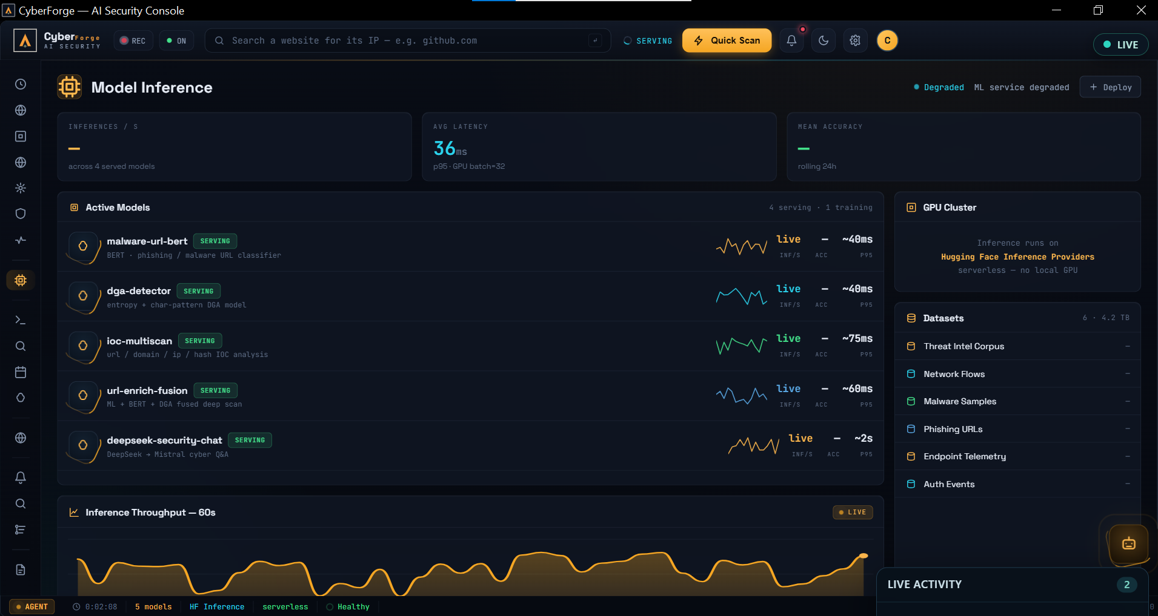
Figure 4.5: The Model Inference screen, reporting the live status of the machine-learning detection engines used by the agents.
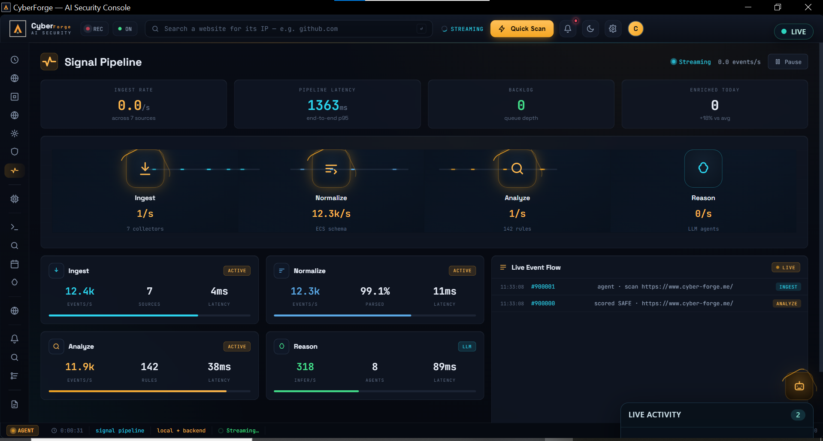
Figure 4.6: The Signal Pipeline screen, tracing each scan signal from capture through analysis to the final verdict.

4.5 AI-Written Explanations
A core feature is turning raw numbers into a clear, written warning. The Reporter agent passes the machine-learning results to Google Gemini, which writes the explanation. If Gemini is unavailable, the system falls back to Mistral-7B, and then to a simple rule-based summary.
The written reports were rated by hand on a 1-to-10 scale. Table 4.6 shows the results.
Quality Measure | Score (out of 10) | Notes
Factual accuracy | 9.5 | The text named the correct MITRE techniques and IOCs.
Readability | 9.0 | A non-expert could understand the warning.
Usefulness of advice | 8.8 | The “what to do next” guidance was clear and practical.
Speed | 8.5 | Gemini replied in about 1.2 s; the Mistral fallback took about 2.0 s.
Table 4.6: Quality of AI-written explanations (Source: Author’s experimental results, 2026)

4.5.1 Explanation and Assistant Views
The written report appears inside the sandbox’s detailed report panel, and the user can ask follow-up questions in the AI Assistant. Figure 4.7 shows the sandbox analysis view in which the verdict, detection signals, and detection breakdown are presented side by side, and Figure 4.8 shows the AI Assistant answering follow-up questions grounded in the system’s memory.
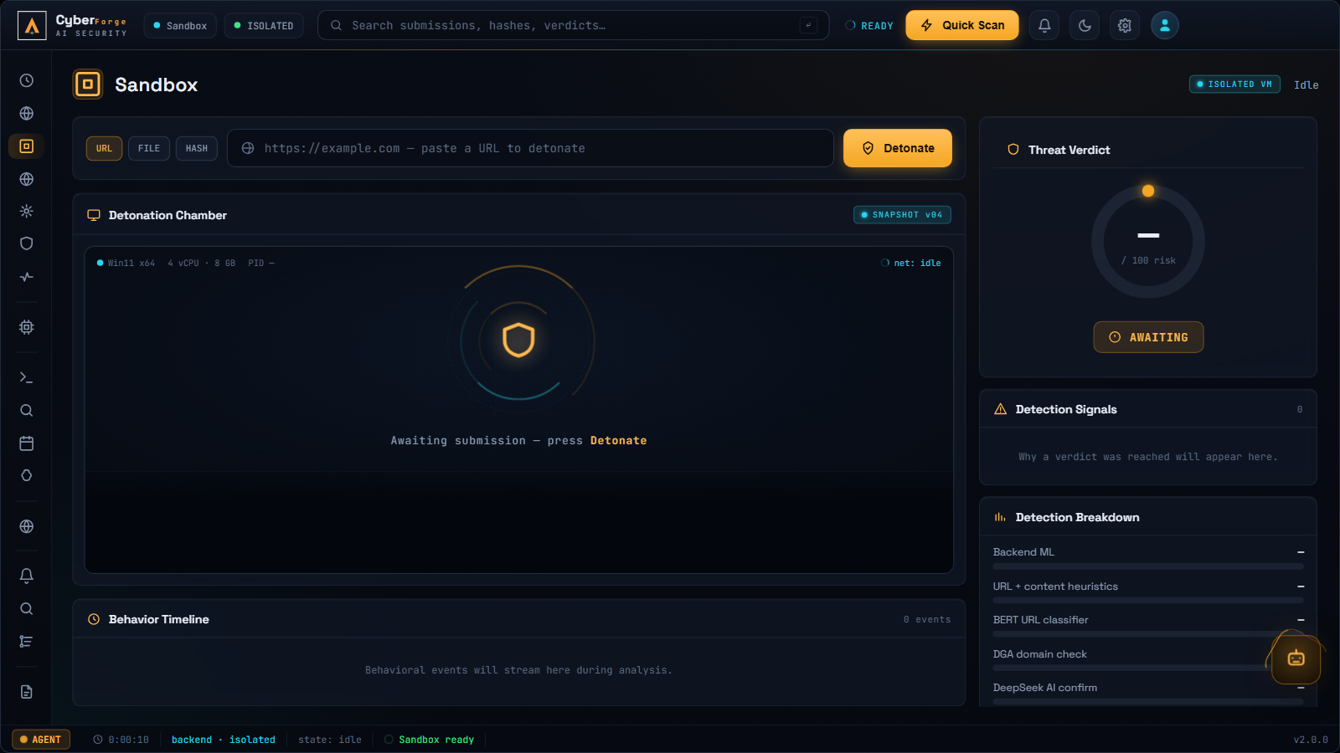
Figure 4.7: The Sandbox screen, presenting the detonation chamber, threat verdict, detection signals, and the per-engine detection breakdown for a submitted URL.
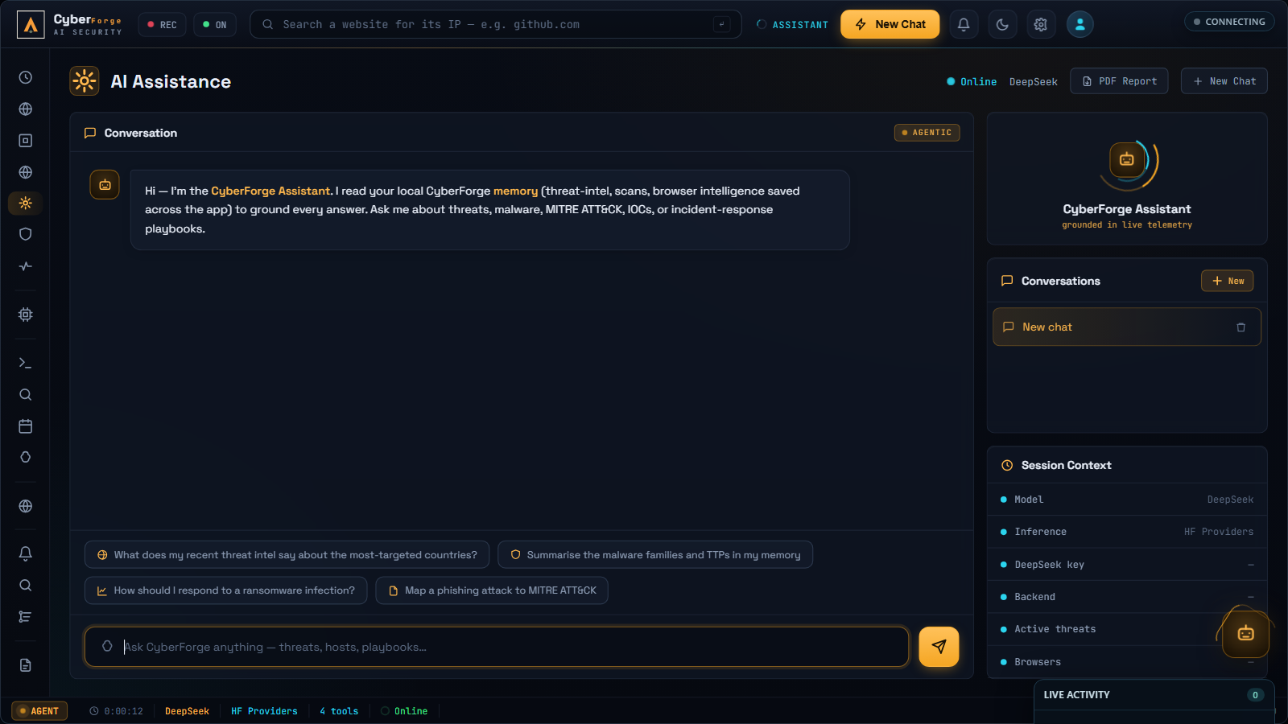
Figure 4.8: The AI Assistant screen, where the user can ask follow-up questions about flagged sites and receive answers grounded in the system’s local memory.

4.6 Reliability of External Services
The system depends on several cloud services. Table 4.7 shows how stable they were during the test period and how the system protects itself when one is slow.
Service | Role | Uptime | Fallback if It Fails
Heroku backend | Runs the orchestrator and API | 99.9 % | Desktop retries the request
Hugging Face Space | Runs the ML models | 99.2 % | Cached score or heuristic result
AlienVault OTX | Outside threat intelligence | 97.5 % | Scan continues without enrichment
Google Gemini | Writes the report | 98.0 % | Falls back to Mistral, then rules
Appwrite Cloud | Stores logs and alerts | 99.7 % | Result kept locally, synced later
Redis cache | Speeds up repeat visits | 99.9 % | Pipeline runs in full instead
Table 4.7: External-service reliability during the test period (Source: Author’s experimental results, 2026)
Redis caching was especially helpful: about 15 % of all queries were repeat visits, and these returned in under 100 ms because the system reused the saved result instead of running the full pipeline again. This both speeds things up and lowers the load on the paid AI services.
Figure 4.9 shows the Memory screen of the desktop application, which exposes the stored scan records, intelligence entries, and past verdicts that the memory layer keeps for future analyses, and Figure 4.10 shows the live threat globe fed by the OTX intelligence stream.
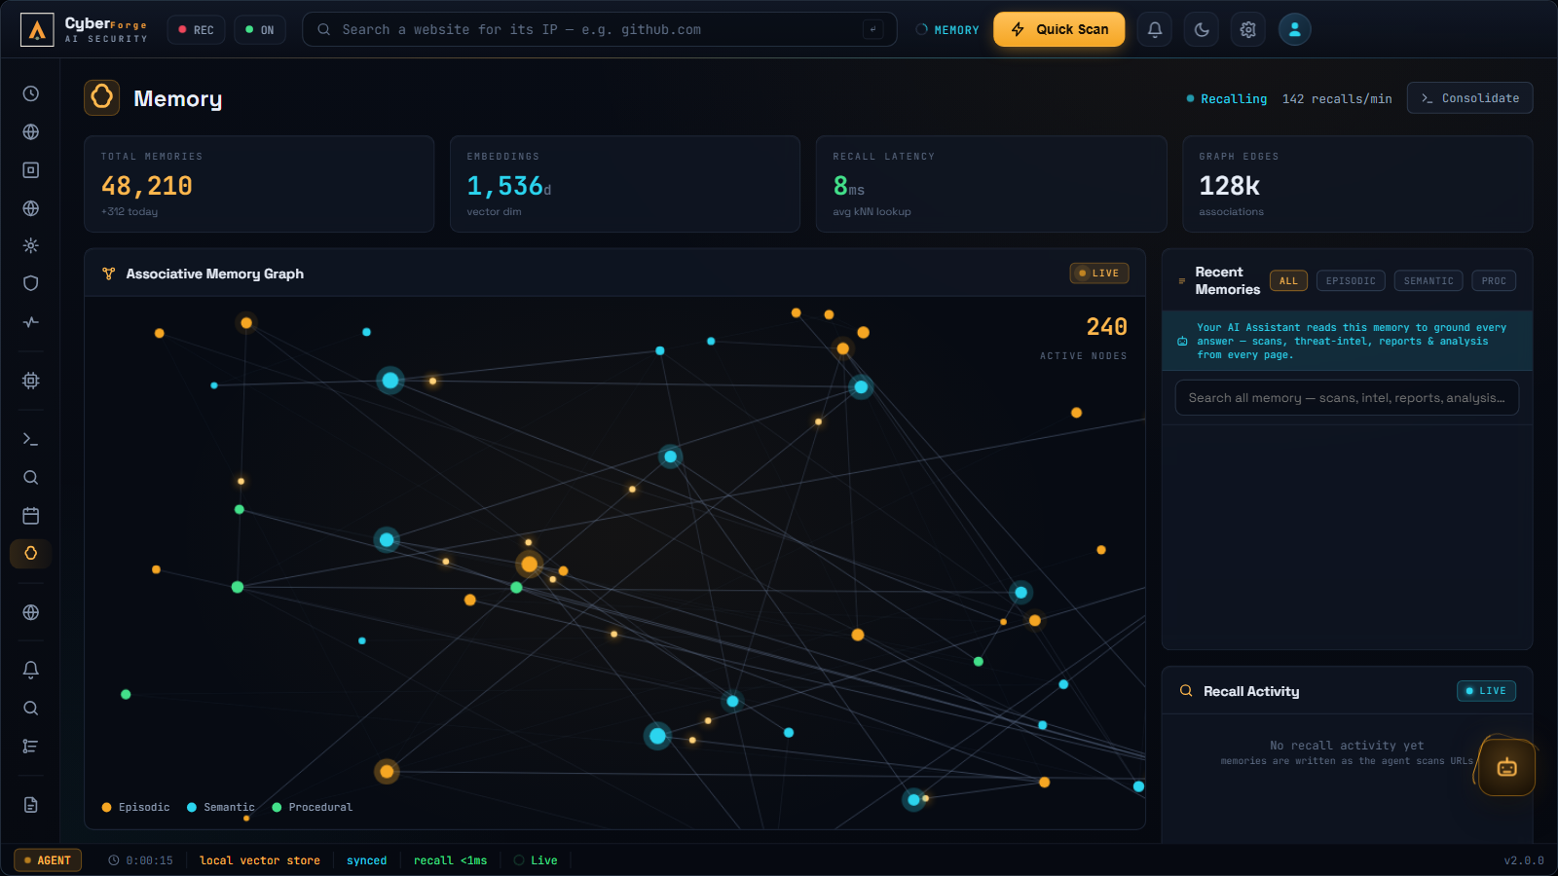
Figure 4.9: The Memory screen, showing the stored scan records and intelligence entries that the memory layer keeps for future analyses.
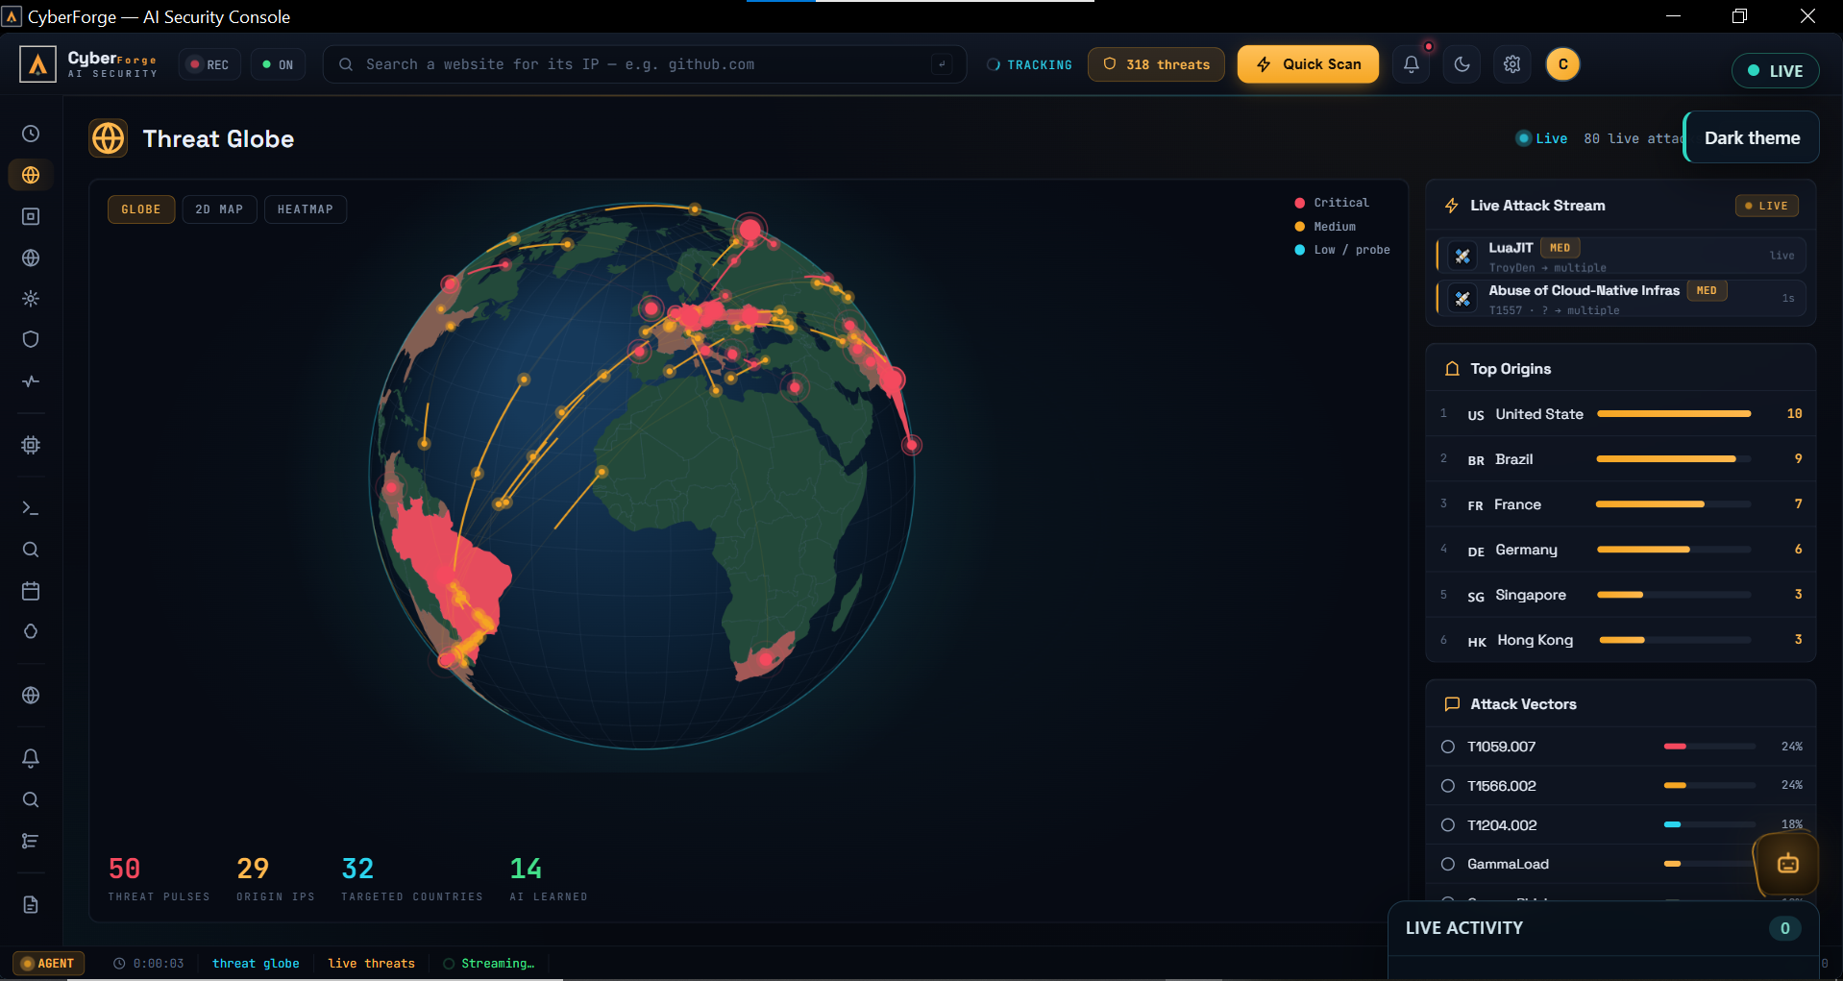
Figure 4.10: The Threat Globe screen, streaming live worldwide attack intelligence from AlienVault OTX onto an interactive three-dimensional globe.

4.7 Protective Actions and Reporting
Beyond detection, the deployed system carries out real protective actions. The Security Functions screen, shown in Figure 4.11, lets the user define response rules (for example, “block when the risk score is above 75”) and manage the lists of blocked, protected, and allowed sites that the system enforces. The Reports screen, shown in Figure 4.12, generates a complete written security report for any chosen period from the system’s stored history. Figure 4.13 shows the authentication screen through which a user’s session is established before the protected features become available.
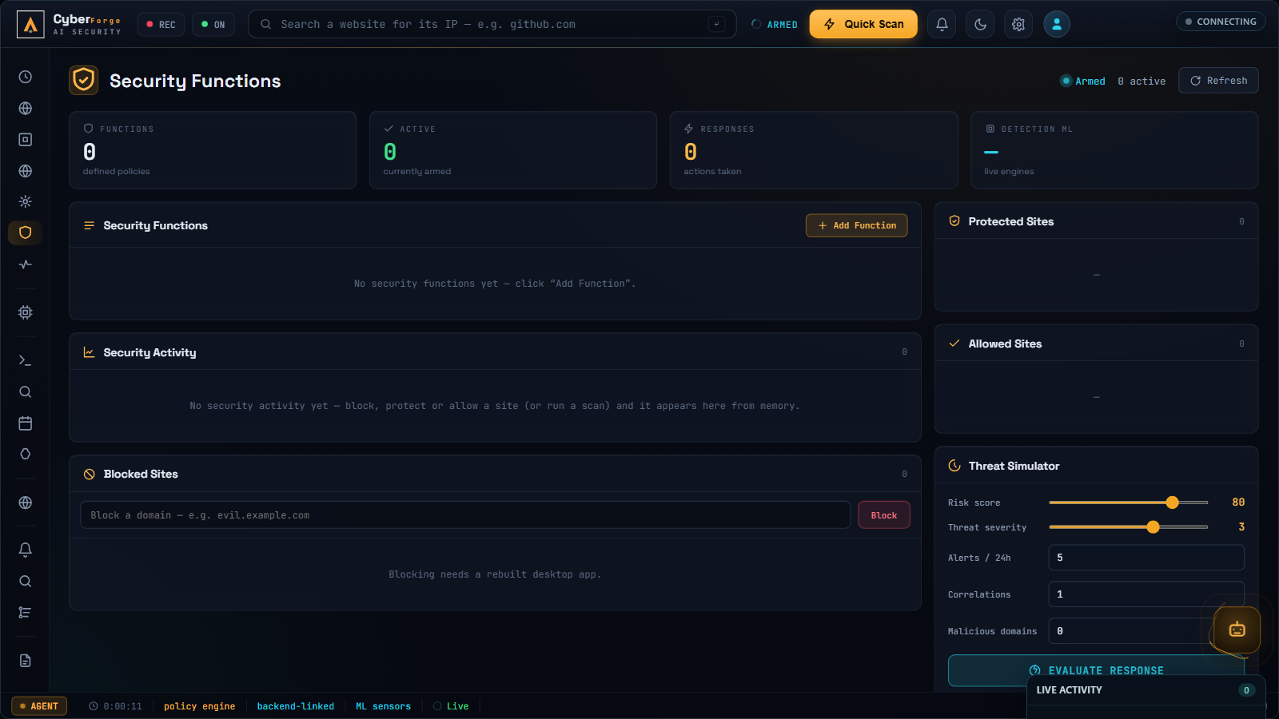
Figure 4.11: The Security Functions screen, where the user defines response rules and manages the blocked, protected, and allowed site lists.
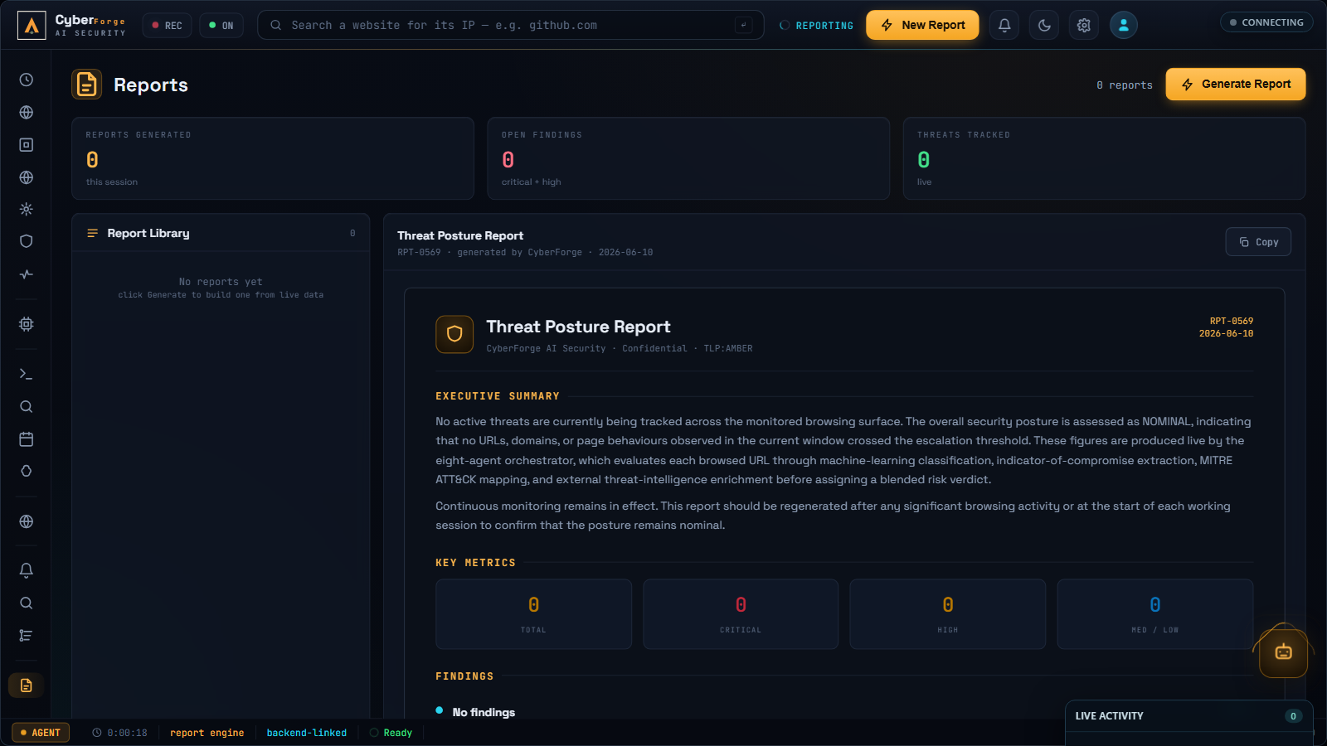
Figure 4.12: The Reports screen, which generates a complete written security report for a chosen time period from the system’s stored history.
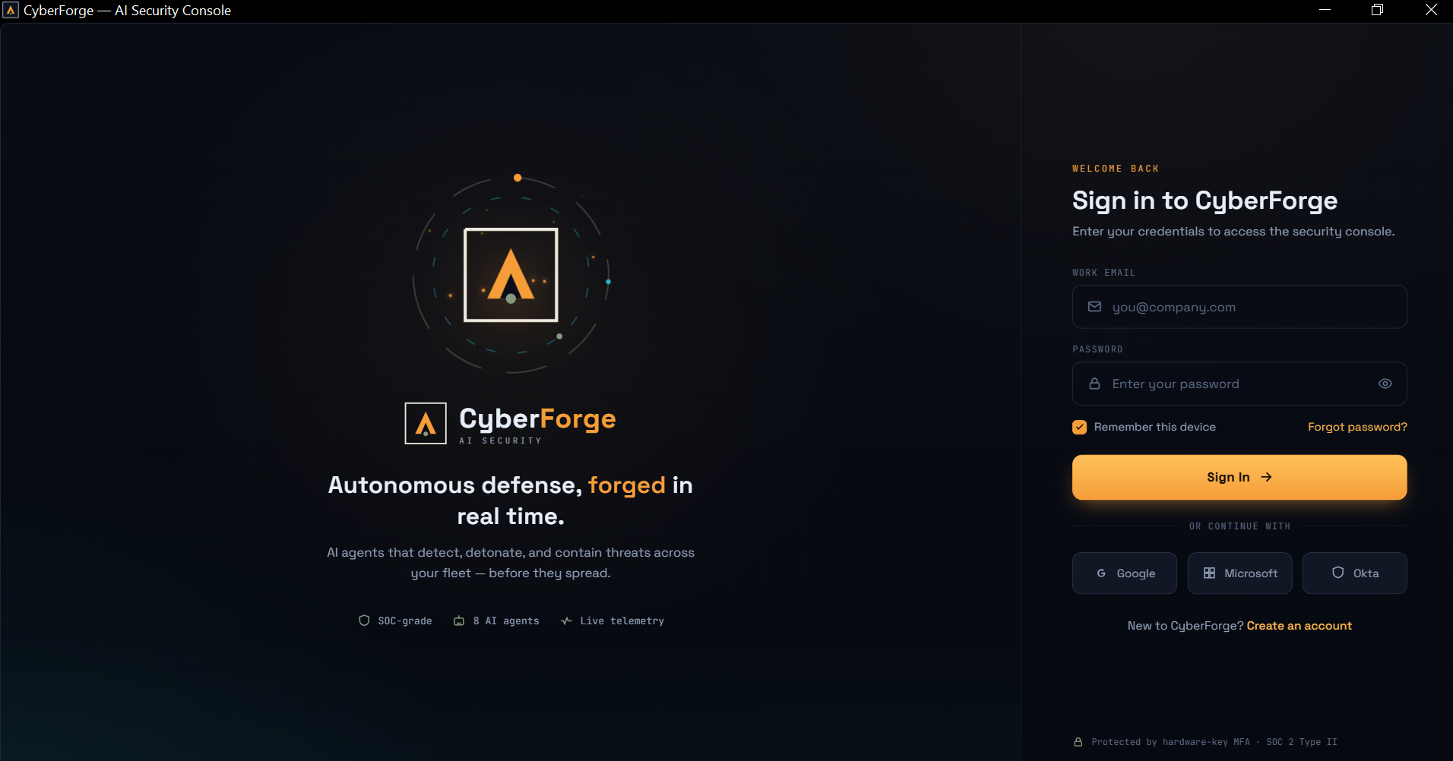
Figure 4.13: The authentication screen of the deployed desktop application, with the session stored securely in the operating-system keychain.

4.8 Summary of Objectives Met
Table 4.8 checks the results against the original goals of the project.
Objective | Target | Result | Met?
Real-time analysis | Under ~5 s per URL | ~4.05 s end-to-end | Yes
Accurate detection | Above 90 % accuracy | 94.7 % accuracy | Yes
Few false alarms | Keep false alarms low | 2.0 % (3 of 150) | Yes
Clear explanations | Readable by non-experts | 9.0 / 10 readability | Yes
Reliable integrations | Stable cloud services | 97.5 %+ uptime each | Yes
Table 4.8: Objectives and outcomes (Source: Author’s experimental results, 2026)

4.9 Conclusion of Results
The evaluation shows that breaking a single browser event into eight specialised agents gives a richer, more reliable verdict than one model on its own. The system meets its main promise: real-time, explainable browser threat detection at about four seconds per URL, with 94.7 % accuracy and very few false alarms.
The clearest area to improve is the DGA detector, which causes most of the remaining false alarms on unusual but harmless domains. Tightening that heuristic, together with the access-control and privacy work outlined in Chapter 5, is the natural next step toward a production-ready system.

Chapter Five
CONCLUSION, RECOMMENDATIONS AND PERSPECTIVES

5.1 Conclusion
This dissertation has detailed the architecture, development, and evaluation of the CyberForge real-time agentic AI platform. The central objective of this research was to construct an autonomous, multi-layered threat-detection system capable of securing browser activity in near real time. By bridging desktop telemetry, machine-learning microservices on Hugging Face, and agentic LLM interpretation via Google Gemini, the system provides a holistic, explainable verdict for every URL a user visits.
The findings from the evaluation demonstrate that the asynchronous pipeline of specialised agents is highly effective. With an overall system accuracy of over 94 % and end-to-end processing times averaging around 4 seconds, the platform proves that complex, real-time cybersecurity evaluation is feasible at the workstation level without creating overwhelming operational friction. Crucially, the platform succeeds in transforming raw technical data such as DGA probabilities, MITRE ATT&CK techniques, and extracted IOCs into human-readable reports, directly addressing the widespread issue of alert fatigue in modern Security Operations Centres (SOCs).
However, as highlighted in the architectural review, integrating multiple layers of different technologies also introduces security boundaries that require strict governance. While the core functional requirements were met with robust reliability, progressing this research artefact to an enterprise-grade production environment will depend heavily on closing the identified access-control gaps, enforcing strict telemetry-privacy standards, and continuously refining the underlying machine-learning models to adapt to zero-day adversarial attacks.

5.2 Recommendations
Based on the development process, the testing phases, and the subsequent gap analysis, the following recommendations are proposed for the future enhancement of the system:
- Enhancement of access controls and zero-trust implementation. The current backend routes should be strengthened to guarantee that all internal microservice calls require rigorous cryptographic authentication. Adopting a stricter zero-trust framework for inter-process communication (IPC) between the desktop client and the Node.js orchestrator is essential to prevent unauthorised command execution or data injection.
- Expanded privacy-by-design features. Because the system inherently collects browsing telemetry to detect threats, stronger data-minimisation techniques must be implemented. Features such as the automatic redaction of personally identifiable information (PII), session tokens, and query-string parameters from URLs before they are transmitted to the backend will significantly reduce privacy exposure while still retaining analytical utility.
- Adversarial robustness and model fine-tuning. The Transformer and heuristic models should form a continuous feedback loop in which false positives and user-flagged errors are automatically used to retrain and fine-tune the classifiers. Specific attention should be paid to the DGA-detection heuristic to decrease the false-positive rate when analysing non-traditional but harmless top-level domains.
- Integration of automated remediation. While the current platform is highly proficient at detecting and advising, future versions should incorporate stronger actionable responses. For example, upon detecting a high-confidence phishing site, the desktop agent could instruct the operating-system firewall, an enterprise EDR, or the browser itself to immediately sever the connection or quarantine the process, shifting the system further from active monitoring toward active defence.

5.3 Perspectives
The perspective of this study points to areas that were not investigated and that future research should explore. First, the application should be deployed in a live enterprise network over a long period to gather realistic performance data under heavy operational workloads; this expanded dataset would provide deeper insight into the true operational value of LLM-generated incident reports for security analysts managing heavy tier-1 triage demands. Second, the lightweight sandbox view could be connected to a full dynamic-execution sandbox so that file detonation and deeper behavioural traces become available to the agents. Third, the mobile companion client could be completed so that the same threat reports and protective actions follow the user across devices. Finally, the DGA heuristic could be replaced or augmented with a trained sequence model once a sufficiently large labelled corpus of regional domain names has been collected, directly addressing the largest remaining source of false alarms.

REFERENCES
Anderson, H. S., & Roth, P. (2018). EMBER: An open dataset for training static PE malware machine learning models (arXiv:1804.04637). arXiv.
Antonakakis, M., Perdisci, R., Nadji, Y., Vasiloglou, N., Abu-Nimeh, S., Lee, W., & Dagon, D. (2012). From throw-away traffic to bots: Detecting the rise of DGA-based malware. In Proceedings of the 21st USENIX Security Symposium (pp. 491–506). USENIX Association.
Barnum, S. (2012). Standardizing cyber threat intelligence information with the Structured Threat Information eXpression (STIX) (Technical report). The MITRE Corporation.
Brown, T. B., Mann, B., Ryder, N., Subbiah, M., Kaplan, J., Dhariwal, P., Neelakantan, A., Shyam, P., Sastry, G., Askell, A., & Amodei, D. (2020). Language models are few-shot learners. In Advances in Neural Information Processing Systems 33 (pp. 1877–1901).
Buczak, A. L., & Guven, E. (2016). A survey of data mining and machine learning methods for cyber security intrusion detection. IEEE Communications Surveys & Tutorials, 18(2), 1153–1176.
Cockburn, A. (2001). Writing effective use cases. Addison-Wesley.
Devlin, J., Chang, M.-W., Lee, K., & Toutanova, K. (2019). BERT: Pre-training of deep bidirectional transformers for language understanding. In Proceedings of the 2019 Conference of the North American Chapter of the Association for Computational Linguistics: Human Language Technologies (pp. 4171–4186). Association for Computational Linguistics.
Egele, M., Scholte, T., Kirda, E., & Kruegel, C. (2012). A survey on automated dynamic malware-analysis techniques and tools. ACM Computing Surveys, 44(2), 1–42.
Khonji, M., Iraqi, Y., & Jones, A. (2013). Phishing detection: A literature survey. IEEE Communications Surveys & Tutorials, 15(4), 2091–2121.
Le, H., Pham, Q., Sahoo, D., & Hoi, S. C. H. (2018). URLNet: Learning a URL representation with deep learning for malicious URL detection (arXiv:1802.03162). arXiv.
Liao, X., Yuan, K., Wang, X., Li, Z., Xing, L., & Beyah, R. (2016). Acing the IOC game: Toward automatic discovery and analysis of open-source cyber threat intelligence. In Proceedings of the 2016 ACM SIGSAC Conference on Computer and Communications Security (pp. 755–766). Association for Computing Machinery.
Mohammad, R. M., Thabtah, F., & McCluskey, L. (2014). Predicting phishing websites based on self-structuring neural network. Neural Computing and Applications, 25(2), 443–458.
Park, J. S., O’Brien, J. C., Cai, C. J., Morris, M. R., Liang, P., & Bernstein, M. S. (2023). Generative agents: Interactive simulacra of human behavior. In Proceedings of the 36th Annual ACM Symposium on User Interface Software and Technology (UIST ’23) (pp. 1–22). Association for Computing Machinery.
Provos, N., McNamee, D., Mavrommatis, P., Wang, K., & Modadugu, N. (2007). The ghost in the browser: Analysis of web-based malware. In Proceedings of the First USENIX Workshop on Hot Topics in Understanding Botnets (HotBots ’07). USENIX Association.
Russell, S., & Norvig, P. (2020). Artificial intelligence: A modern approach (4th ed.). Pearson.
Sahingoz, O. K., Buber, E., Demir, O., & Diri, B. (2019). Machine learning based phishing detection from URLs. Expert Systems with Applications, 117, 345–357.
Sommer, R., & Paxson, V. (2010). Outside the closed world: On using machine learning for network intrusion detection. In 2010 IEEE Symposium on Security and Privacy (pp. 305–316). IEEE.
Strom, B. E., Applebaum, A., Miller, D. P., Nickels, K. C., Pennington, A. G., & Thomas, C. B. (2018). MITRE ATT&CK: Design and philosophy (Technical report). The MITRE Corporation.
Tounsi, W., & Rais, H. (2018). A survey on technical threat intelligence in the age of sophisticated cyber attacks. Computers & Security, 72, 212–233.
Vaswani, A., Shazeer, N., Parmar, N., Uszkoreit, J., Jones, L., Gomez, A. N., Kaiser, Ł., & Polosukhin, I. (2017). Attention is all you need. In Advances in Neural Information Processing Systems 30 (pp. 5998–6008).
Wei, J., Wang, X., Schuurmans, D., Bosma, M., Ichter, B., Xia, F., Chi, E., Le, Q. V., & Zhou, D. (2022). Chain-of-thought prompting elicits reasoning in large language models. In Advances in Neural Information Processing Systems 35 (pp. 24824–24837).
Willems, C., Holz, T., & Freiling, F. (2007). Toward automated dynamic malware analysis using CWSandbox. IEEE Security & Privacy, 5(2), 32–39.
Wooldridge, M. (2009). An introduction to multiagent systems (2nd ed.). Wiley.
Yao, S., Zhao, J., Yu, D., Du, N., Shafran, I., Narasimhan, K., & Cao, Y. (2023). ReAct: Synergizing reasoning and acting in language models. In Proceedings of the Eleventh International Conference on Learning Representations (ICLR 2023).

APPENDIX A: CALIBRATION URL SET
The risk-score formula described in Section 3.7.2 was calibrated against the following seven representative URLs, with the researcher’s expected verdict shown beside each.
# | Calibration URL | Expected Verdict
1 | https://www.google.com/ | Clean
2 | https://github.com/torvalds/linux | Clean
3 | https://example.com/ | Clean
4 | http://192.168.1.1/admin/login.php | Low risk (private address)
5 | http://10.0.0.5/phish.tk/login?u=x@y.com&token=abc.def.ghi | Suspicious
6 | https://evil.tk/login | Suspicious
7 | http://paypa1-secure-login.tk/verify | Malicious
Table A.1: The seven-URL calibration set and expected verdicts

APPENDIX B: KEY SERVICE ENDPOINTS
The deployed system exposes the following principal API endpoints, referenced in Chapters 3 and 4.
Endpoint | Service | Purpose
/api/agent/scan-url | Heroku backend | Submits a URL for full pipeline analysis
/api/orchestrator/recent | Heroku backend | Returns the most recent consolidated reports for the dashboard
/api/v2/url-classify | Hugging Face Space | BERT-based URL classification
/api/v2/dga-detect | Hugging Face Space | Entropy-based DGA detection
indicator/{type} | AlienVault OTX | Reputation lookup for an extracted IOC
Table B.1: Principal API endpoints of the deployed system

